A

Project Report

On

STUDENT PORTAL

Submitted in partial fulfillment of the requirement for the degree of

Bachelor of Computer Application & North University.

Submitted by

NARESH

KARTHIK V

MALLIKARJUN

Under the esteemed guidance of

Prof. Chandrasekhar

BCA Dept

Associate Professor



Government First Grade College / KR Puram /Bengaluru- 560 036.

Department of Bachelor of Computer Application



|  |
| --- |
| STUDENT PORTAL  2025 |
|  |
| May 12  GFGC KR PURAM  Authored by: KARTHIK V |



Full-Stack Student Portal with Role-Based Dashboards

Executive Summary

This report details the design, development, and deployment of a Full-Stack Student Portal application that supports three distinct user roles: Students, Teachers, and Administrators. Each user role has tailored access and dashboards, facilitating academic and administrative tasks.

The application is built using a modern JavaScript stack, including:

* Frontend: Next.js
* Backend: Express.js and Node.js
* Database: MongoDB Atlas
* Authentication: NextAuth.js with JWT
* UI Design: Tailwind CSS
* Deployment: Vercel and Render/Heroku

This system incorporates best practices in:

* Role-Based Access Control (RBAC)
* Responsive UI Design
* Secure Deployment Strategies

Table of Contents

1. Introduction
2. Literature Review
3. System Requirements
4. System Design
5. Architecture Overview
6. Technical Stack
7. Data Modeling
8. API Design
9. RBAC Implementation
10. Authentication System
11. Frontend Implementation
12. Dashboard Features
13. Student Role Functionality
14. Teacher Role Functionality
15. Admin Role Functionality
16. State Management
17. UI/UX Design Principles
18. Accessibility Considerations
19. Performance Optimization
20. Testing Strategies
21. CI/CD Pipeline
22. Deployment Strategy
23. Security Measures
24. Error Handling
25. Monitoring and Logging
26. Database Management
27. Schema Migrations
28. Data Validation
29. User Input Sanitization
30. Real-Time Features
31. Notification System
32. Assignment Management
33. Attendance Tracking
34. Grade Management
35. Course Management
36. Query System
37. Reporting System
38. Analytics Dashboard
39. Mobile Responsiveness
40. Responsive Layout Design
41. Integration with Third-Party Services
42. Documentation Practices
43. Developer Guidelines
44. Version Control Strategy
45. Sprint Planning
46. Task Management Tools
47. Project Timeline
48. Resource Allocation
49. Team Collaboration
50. Lessons Learned
51. Challenges Faced
52. Future Enhancements
53. Feature Roadmap
54. Feedback Incorporation
55. User Surveys
56. Case Studies
57. Comparative Analysis
58. Technical Debt Management
59. Code Refactoring
60. Modular Architecture
61. Component Reusability
62. Code Review Process
63. Git Workflow
64. Deployment Checklist
65. Environment Variables
66. Configuration Management
67. API Rate Limiting
68. Throttling Strategies
69. Caching Mechanisms
70. SEO Optimization
71. Server-Side Rendering
72. Static Site Generation
73. Middleware Usage
74. Load Testing
75. Stress Testing
76. Authentication Flows
77. Session Management
78. Data Backup Plan
79. Disaster Recovery
80. Role Upgrade Flow
81. User Deactivation Flow
82. Multi-Language Support
83. Custom Hooks in React
84. HOC for Route Protection
85. Dynamic Routing
86. Nested Routes
87. Form Handling
88. File Upload Features
89. Assignment Submission Flow
90. Database Indexing
91. MongoDB Aggregation
92. Hosting Services Comparison
93. DevOps Practices
94. Audit Trails
95. GDPR Compliance
96. Code Linting and Formatting
97. Codebase Scalability
98. Summary and Conclusion
99. References and Appendices

Table of Contents

1. Introduction

* Background on student portals
* Objectives of the project
* Overview of role-based access

2. Literature Review

* Existing student portals and their limitations
* Comparison with industry standards
* Research on best practices in full-stack development

3. System Requirements

* Functional and non-functional requirements
* User stories and use cases
* Performance and scalability expectations

4. System Design

* High-level system architecture
* Design principles followed
* Wireframes and mockups

5. Architecture Overview

* Microservices vs. monolithic architecture
* API-first approach
* Scalability considerations

6. Technical Stack

* Justification for choosing Next.js, Express.js, and MongoDB
* Alternative technologies considered
* Comparison of different backend frameworks

7. Data Modeling

* ER diagrams and schema design
* Normalization and indexing strategies
* Handling relationships between entities

8. API Design

* REST vs. GraphQL considerations
* Endpoint documentation
* Rate limiting and security measures

9. RBAC Implementation

* Role hierarchy and permissions
* Middleware for access control
* Real-world examples of RBAC usage

10. Authentication System

* JWT vs. OAuth comparison
* Secure password storage techniques
* Multi-factor authentication implementation

11. Frontend Implementation

* Component-based architecture in React
* State management strategies
* Responsive UI development

12. Dashboard Features

* Overview of dashboards for different roles
* Customization options
* Performance optimization techniques

13-16. Role-Based Functionalities

* Detailed breakdown of student, teacher, and admin functionalities
* Screenshots and workflow diagrams
* Edge cases and error handling

17. State Management

* Redux vs. Context API comparison
* Handling asynchronous data fetching
* Optimizing state updates

18. UI/UX Design Principles

* Accessibility best practices
* Color schemes and typography choices
* User feedback incorporation

19. Accessibility Considerations

* WCAG compliance strategies
* Keyboard navigation and screen reader support
* Testing accessibility features

20. Performance Optimization

* Lazy loading and code splitting
* Database query optimization
* Frontend rendering improvements

21. Testing Strategies

* Unit, integration, and end-to-end testing
* Automated testing tools
* Test-driven development (TDD) approach

22. CI/CD Pipeline

* GitHub Actions vs. Jenkins comparison
* Deployment automation
* Rollback strategies

23. Deployment Strategy

* Vercel vs. Render vs. Heroku comparison
* Environment variable management
* Zero-downtime deployment techniques

24. Security Measures

* OWASP top 10 vulnerabilities mitigation
* Secure API communication
* Data encryption strategies

25. Error Handling

* Logging and monitoring errors
* User-friendly error messages
* Debugging techniques

26. Monitoring and Logging

* Tools like Prometheus and Grafana
* Log aggregation strategies
* Real-time monitoring dashboards

27. Database Management

* Backup and recovery strategies
* Schema evolution techniques
* Handling large datasets efficiently

28. Schema Migrations

* Versioning database schemas
* Migration tools like Mongoose
* Handling backward compatibility

29. Data Validation

* Server-side vs. client-side validation
* Preventing SQL injection and XSS attacks
* Using libraries like Joi for validation

30. User Input Sanitization

* Preventing malicious inputs
* Using security libraries
* Case studies of security breaches

31. Real-Time Features

* WebSockets vs. polling
* Implementing live chat and notifications
* Performance considerations

32. Notification System

* Push notifications vs. email alerts
* Integration with third-party services
* User preferences management

33-36. Academic Features

* Assignment submission and grading workflows
* Attendance tracking mechanisms
* Course and query management strategies

37. Reporting System

* Generating reports dynamically
* Exporting data in multiple formats
* Performance optimization for large reports

38. Analytics Dashboard

* Visualizing student performance
* Using charting libraries like Chart.js
* Predictive analytics implementation

39-41. Mobile Responsiveness

* Adaptive design techniques
* Mobile-first development approach
* Testing on different screen sizes

42. Integration with Third-Party Services

* Payment gateways for course fees
* LMS integration
* External API usage

43-45. Documentation & Developer Guidelines

* Writing effective documentation
* Code commenting best practices
* Maintaining API documentation

46-50. Project Management

* Agile vs. Waterfall methodologies
* Sprint planning and retrospectives
* Team collaboration tools

51-56. Lessons Learned & Feedback

* Challenges faced during development
* User feedback incorporation
* Case studies of similar projects

57-60. Code Quality & Refactoring

* Managing technical debt
* Modular architecture benefits
* Code review best practices

61-65. Git Workflow & Deployment Checklist

* Branching strategies
* CI/CD integration with Git
* Pre-deployment checks

66-70. Performance & Security Enhancements

* API rate limiting strategies
* Caching mechanisms for optimization
* SEO improvements

71-75. Server-Side Rendering & Load Testing

* SSR vs. SSG comparison
* Stress testing methodologies
* Middleware usage for optimization

76-80. Authentication & Disaster Recovery

* Session management techniques
* Data backup strategies
* Handling user role upgrades

81-85. Advanced React Features

* Custom hooks for optimization
* Higher-order components for protection
* Dynamic routing strategies

86-90. Form Handling & File Uploads

* Managing complex forms efficiently
* Secure file upload techniques
* Assignment submission workflows

91-95. Database Optimization & DevOps

* Indexing strategies for MongoDB
* Aggregation pipelines for analytics
* DevOps best practices

96-100. Compliance & Scalability

* GDPR compliance strategies
* Code linting and formatting
* Future scalability considerations

1. Introduction

Background on Student Portals

Student portals are centralized digital platforms designed to streamline and enhance the academic experience for students, faculty, and administrative staff. These portals serve as a hub for accessing essential academic resources, including course materials, grades, timetables, financial statements, and communication tools. By consolidating various services into a single interface, student portals aim to improve efficiency, reduce administrative burdens, and foster better engagement within educational institutions. The development of such portals is often driven by the need to adapt to the digital age and meet the evolving expectations of today's learners .[IJRPR](https://ijrpr.com/uploads/V5ISSUE5/IJRPR28534.pdf?utm_source=chatgpt.com)

Objectives of the Project

The primary objectives of developing a student portal with integrated role-based access control (RBAC) include:

* Centralization of Information: Providing a unified platform where students, faculty, and staff can access relevant academic and administrative information.
* Enhanced Security and Privacy: Implementing RBAC to ensure that users can only access data pertinent to their roles, thereby protecting sensitive information.[Oracle Documentation+9Imperva+9LearningOS+9](https://www.imperva.com/learn/data-security/role-based-access-control-rbac/?utm_source=chatgpt.com)
* Improved User Experience: Designing an intuitive interface that caters to the specific needs of different user groups, ensuring ease of navigation and interaction.
* Scalability and Flexibility: Creating a system that can accommodate future growth and adapt to the changing requirements of the institution.
* Compliance and Accountability: Ensuring that the portal adheres to relevant regulations and standards, and providing mechanisms for tracking user activities to maintain accountability.

Overview of Role-Based Access Control (RBAC)

Role-Based Access Control (RBAC) is a security model that restricts system access to authorized users based on their roles within an organization. In the context of a student portal, RBAC assigns specific permissions to users such as students, faculty, and administrators, ensuring they can only access information and perform actions relevant to their roles .[Foxpass+3Wikipedia+3Imperva+3](https://en.wikipedia.org/wiki/Role-based_access_control?utm_source=chatgpt.com)[Imperva](https://www.imperva.com/learn/data-security/role-based-access-control-rbac/?utm_source=chatgpt.com)

Key Components of RBAC:

* Roles: Defined categories that represent a set of responsibilities within the institution (e.g., Student, Instructor, Administrator).
* Permissions: The rights or privileges assigned to roles, dictating what actions can be performed (e.g., view grades, submit assignments).
* Users: Individuals assigned to one or more roles, thereby inheriting the associated permissions.
* Sessions: Active instances where users interact with the system, during which they assume specific roles.

Benefits of Implementing RBAC in a Student Portal:

* Security: By limiting access based on roles, RBAC minimizes the risk of unauthorized access to sensitive data.[LearningOS+1Zuar+1](https://www.thelearningos.com/enterprise-knowledge/role-based-access-control-in-lms-a-comprehensive-guide?utm_source=chatgpt.com)
* Efficiency: Streamlines the management of user permissions, making it easier to grant or revoke access as roles change.[LearningOS+1Wikipedia+1](https://www.thelearningos.com/enterprise-knowledge/role-based-access-control-in-lms-a-comprehensive-guide?utm_source=chatgpt.com)
* Compliance: Helps institutions adhere to regulatory requirements by enforcing strict access controls.[LearningOS](https://www.thelearningos.com/enterprise-knowledge/role-based-access-control-in-lms-a-comprehensive-guide?utm_source=chatgpt.com)
* User Experience: Ensures that users are presented with information and tools pertinent to their roles, reducing clutter and confusion.

In summary, integrating RBAC into a student portal not only enhances security and compliance but also improves the overall user experience by providing tailored access to resources and functionalities.

2. Literature Review

Existing Student Portals and Their Limitations

Student portals are integral to modern educational institutions, providing centralized access to academic resources, schedules, grades, and communication tools. However, many existing portals exhibit several limitations:

* User Experience (UX) Challenges: A study analyzing the accessibility of Indian educational web portals found that many fail to adhere to Web Content Accessibility Guidelines (WCAG) 2.0, leading to usability issues for students with disabilities .[arXiv](https://arxiv.org/abs/1710.07899?utm_source=chatgpt.com)
* Performance Issues: Some portals suffer from slow load times and unresponsive interfaces, particularly on mobile devices, affecting user engagement and satisfaction.
* Security Concerns: Weak authentication mechanisms and inadequate data protection measures can expose sensitive student information to unauthorized access.
* Lack of Personalization: Many portals offer a one-size-fits-all approach, lacking customization options that cater to individual student needs and preferences.

Comparison with Industry Standards

Leading student portals in the industry often set benchmarks in various aspects:

* User-Centric Design: Portals like those of Stanford University and the University of California, Berkeley, prioritize intuitive navigation, responsive design, and accessibility, ensuring a seamless user experience across devices.
* Robust Security Frameworks: These institutions implement multi-factor authentication, data encryption, and regular security audits to safeguard user data .[Magic Technolabs](https://www.magictechnolabs.com/blog/security-first-10-best-practices-for-full-stack-development-security/?utm_source=chatgpt.com)
* Role-Based Access Control (RBAC): Advanced RBAC implementations ensure that students, faculty, and staff have access only to the information pertinent to their roles, enhancing security and data integrity.
* Integration with Academic Tools: Industry-leading portals often integrate with Learning Management Systems (LMS), library databases, and financial services, providing a comprehensive academic ecosystem.

Research on Best Practices in Full-Stack Development

Developing a robust student portal requires adherence to best practices in full-stack development:[Web Development](https://www.websitedeveloperz.com/full-stack/10-best-practices-for-efficient-full-stack-development/?utm_source=chatgpt.com)

* Modular Architecture: Breaking down the application into smaller, manageable components facilitates easier maintenance and scalability .[Web Development](https://www.websitedeveloperz.com/full-stack/10-best-practices-for-efficient-full-stack-development/?utm_source=chatgpt.com)
* Agile Methodology: Implementing Agile practices allows for iterative development, enabling teams to adapt to changing requirements and deliver incremental improvements .[Stack Cache+1Expertia+1](https://www.stackcache.io/bootcamps/top-10-best-practices-for-fullstack-development-in-2024/?utm_source=chatgpt.com)
* Continuous Integration and Deployment (CI/CD): Automating the integration and deployment processes ensures consistent quality and faster delivery cycles .
* Security Measures: Incorporating security best practices, such as input validation, encryption, and regular security audits, is crucial to protect sensitive data .[Magic Technolabs](https://www.magictechnolabs.com/blog/security-first-10-best-practices-for-full-stack-development-security/?utm_source=chatgpt.com)
* Responsive Design: Ensuring the portal is accessible and functional across various devices enhances user experience and engagement .[Nucamp](https://www.nucamp.co/blog/coding-bootcamp-full-stack-web-and-mobile-development-top-10-best-practices-for-fullstack-development-in-2024?utm_source=chatgpt.com)

By addressing the limitations of existing portals and aligning with industry standards and best practices, educational institutions can develop student portals that are secure, user-friendly, and capable of meeting the diverse needs of their student populations.

3. System Requirements

Functional and Non-Functional Requirements

Functional Requirements:

Functional requirements define the specific behavior or functions of a system. In the context of a student portal, these include:

* User Authentication and Authorization: Implementing secure login mechanisms for students, faculty, and administrators, ensuring role-based access control.
* Dashboard Access: Providing personalized dashboards displaying relevant information such as grades, attendance, and upcoming assignments.
* Course Management: Allowing students to view enrolled courses, access course materials, and submit assignments.
* Communication Tools: Facilitating communication between students and instructors through messaging systems or forums.
* Notification System: Sending alerts for upcoming deadlines, grades, and institutional announcements.

Non-Functional Requirements:

Non-functional requirements specify how the system performs its tasks, focusing on attributes like performance, security, scalability, and usability. For a student portal, these include:

* Performance: The portal should load within 3 seconds to ensure a responsive user experience.
* Scalability: The system must support up to 10,000 concurrent users without degradation in performance.
* Security: Implementing encryption protocols, secure authentication methods, and regular security audits to protect user data.
* Usability: Designing an intuitive interface that is accessible to users with varying levels of technical proficiency.
* Availability: Ensuring 99.9% uptime to provide reliable access to users.

User Stories and Use Cases

User Stories:

User stories are short, simple descriptions of a feature told from the perspective of the person who desires the new capability. They typically follow the format:

As a [type of user], I want [some goal] so that [some reason].[Parabol+4Mountain Goat Software+4ICPSR+4](https://www.mountaingoatsoftware.com/agile/user-stories?utm_source=chatgpt.com)

Examples for a student portal:

* As a student, I want to view my grades so that I can track my academic progress.
* As an instructor, I want to post announcements so that I can communicate important information to students.
* As an administrator, I want to manage user roles so that I can control access to various features.

Use Cases:

Use cases describe how users interact with the system to achieve a specific goal. They provide detailed steps and scenarios for system behavior.

Example use case: *Viewing Grades*

* Actor: Student[Atlassian+10Student Performance System+10DU Portal+10](https://www.studentperformancesystem.com/?utm_source=chatgpt.com)
* Precondition: Student is logged into the portal.
* Main Flow:
  1. Student navigates to the 'Grades' section.
  2. System displays a list of courses with corresponding grades.
  3. Student selects a course to view detailed grade information.
* Postcondition: Student views detailed grade information for the selected course.

Performance and Scalability Expectations

Performance and scalability are critical aspects of a student portal to ensure it can handle varying loads and provide a seamless user experience.

* Performance: The portal should be optimized to handle peak usage times, such as during registration periods, without significant delays.
* Scalability: The system architecture should support horizontal scaling, allowing additional resources to be added as the number of users grows.
* Load Testing: Regular load testing should be conducted to identify potential bottlenecks and ensure the system can handle the expected number of concurrent users.
* Database Optimization: Implementing indexing, caching, and query optimization techniques to ensure efficient data retrieval and storage.
* Content Delivery Network (CDN): Utilizing a CDN to distribute static content and reduce latency, improving load times for users across different geographical locations.

By addressing these requirements and expectations, the student portal can provide a robust, secure, and user-friendly platform that meets the needs of its diverse user base.

4. System Design

High-Level System Architecture

The high-level architecture of a student portal encompasses several key components that work together to provide a seamless user experience. These components include:

* User Interface (UI): The front-end of the portal, designed to be intuitive and responsive, ensuring accessibility across various devices.
* Application Server: Handles business logic and processes user requests, acting as an intermediary between the UI and the database.
* Database Server: Stores and manages data related to students, courses, grades, and other academic records.
* Authentication Service: Manages user authentication and authorization, ensuring secure access to the portal based on user roles.
* Notification System: Sends alerts and updates to users about important events, deadlines, and announcements.[Squiz+3Medium+3LinkedIn+3](https://kianchuanng.medium.com/ui-ux-the-one-academys-student-portal-app-design-4ce8106bff73?utm_source=chatgpt.com)
* Integration Layer: Facilitates communication with external systems such as Learning Management Systems (LMS), email servers, and payment gateways.

This architecture ensures scalability, security, and maintainability, accommodating the growing needs of educational institutions.

Design Principles Followed

The design of the student portal adheres to several key principles to ensure its effectiveness:

* User-Centric Design: Prioritizing the needs and experiences of the users, ensuring the portal is intuitive and easy to navigate.
* Accessibility: Ensuring the portal is accessible to all users, including those with disabilities, by adhering to Web Content Accessibility Guidelines (WCAG).
* Security: Implementing robust security measures, including encryption, secure authentication, and role-based access control, to protect sensitive data.
* Scalability: Designing the system to handle increasing numbers of users and data, ensuring consistent performance.
* Modularity: Developing the portal in modular components, allowing for easier maintenance and future enhancements.
* Consistency: Maintaining uniform design elements and interactions throughout the portal to provide a cohesive user experience.

By adhering to these principles, the student portal aims to provide a reliable and efficient platform for its users.

Wireframes and Mockups

Wireframes and mockups serve as visual representations of the portal's interface, aiding in the design and development process. They provide a blueprint for the layout and functionality of the portal, ensuring alignment with user needs and expectations.

* Wireframes: Low-fidelity sketches that outline the basic structure and elements of the portal's pages. They focus on layout and functionality without detailed design elements.
* Mockups: High-fidelity, detailed designs that incorporate colors, fonts, and branding elements, providing a realistic preview of the final product.

Tools such as Figma, Adobe XD, and Sketch are commonly used to create wireframes and mockups, facilitating collaboration and iteration during the design process.

By utilizing wireframes and mockups, the development team can ensure the portal meets user requirements and expectations, leading to a more successful implementation.

5. Architecture Overview

Microservices vs. Monolithic Architecture

Monolithic Architecture: In a monolithic architecture, all components of the application are tightly integrated and operate as a single unit. This approach is simpler to develop and deploy initially but can become cumbersome as the application grows. Scaling requires replicating the entire application, and updates to one component necessitate redeploying the whole system. [GeeksforGeeks](https://www.geeksforgeeks.org/monolithic-vs-microservices-architecture/?utm_source=chatgpt.com)

Microservices Architecture: Microservices architecture decomposes the application into smaller, independent services, each responsible for a specific business function. This modular approach allows for more flexible scaling, as individual services can be scaled independently. It also enables teams to develop, deploy, and maintain services autonomously, leading to faster development cycles and easier integration of new technologies. [Kong Inc.](https://konghq.com/blog/learning-center/monolith-vs-microservices?utm_source=chatgpt.com)

Comparison Table:

| FeatureMonolithic ArchitectureMicroservices Architecture |  |  |
| --- | --- | --- |
| Deployment | Single unit | Independent services |
| Scalability | Horizontal scaling of entire app | Independent scaling of services |
| Development Speed | Faster initial development | Potentially slower due to complexity |
| Fault Isolation | Failure in one component affects all | Failures are isolated to individual services |
| Technology Stack | Unified stack | Diverse stacks per service |
| Maintenance | Challenging as app grows | Easier with modular services |
| Performance | Faster internal communication | Possible latency due to inter-service calls |

Microservices architecture is often preferred for large-scale applications like student portals, where scalability, flexibility, and independent deployment of features are crucial.

API-First Approach

An API-first approach prioritizes designing and developing APIs before implementing the application itself. This methodology ensures that APIs are well-defined, consistent, and reusable across different platforms and services.

Benefits:

* Parallel Development: Teams can work concurrently on different components, as the API contracts are established upfront. [Cloud Kinetics+4Swagger+4Contentstack+4](https://swagger.io/resources/articles/adopting-an-api-first-approach/?utm_source=chatgpt.com)
* Consistency: Standardized API designs lead to uniform interfaces, improving integration and reducing errors.
* Faster Time-to-Market: With clear API specifications, development becomes more efficient, accelerating delivery timelines. [Postman API Platform](https://www.postman.com/api-first/?utm_source=chatgpt.com)
* Scalability and Flexibility: APIs facilitate the integration of new features and services without disrupting existing functionalities.
* Improved Developer Experience: Well-documented APIs enhance developer productivity and ease onboarding.

For a student portal, adopting an API-first approach ensures that various services like course management, grading, and notifications can be developed and integrated efficiently, providing a cohesive user experience.

Scalability Considerations

Scalability is a critical factor in the design of a student portal, as it must accommodate varying loads, especially during peak times like exam periods or registration.

Strategies:

* Horizontal Scaling: Deploying multiple instances of services to distribute the load and ensure high availability. [Amazon Web Services, Inc.](https://aws.amazon.com/compare/the-difference-between-monolithic-and-microservices-architecture/?utm_source=chatgpt.com)
* Load Balancing: Implementing load balancers to evenly distribute incoming traffic across server instances, preventing any single server from becoming a bottleneck.
* Database Sharding: Dividing the database into smaller, more manageable pieces to improve performance and scalability.
* Caching: Utilizing caching mechanisms to store frequently accessed data, reducing database load and improving response times.
* Asynchronous Processing: Offloading time-consuming tasks to background processes to enhance user experience and system responsiveness.

By implementing these strategies, a student portal can effectively manage increasing user demands, ensuring consistent performance and reliability.

6. Technical Stack

Justification for Choosing Next.js, Express.js, and MongoDB

Next.js: A React-based framework that facilitates server-side rendering (SSR), static site generation (SSG), and incremental static regeneration (ISR). It enhances performance and SEO, making it ideal for building scalable and SEO-friendly student portals. [Stackademic](https://blog.stackademic.com/the-mongodb-and-next-js-stack-for-beginners-b4394872f5bb?utm_source=chatgpt.com)

Express.js: A minimal and flexible Node.js web application framework that provides a robust set of features for building web and mobile applications. It simplifies routing, middleware integration, and API development, making it a preferred choice for backend services.

MongoDB: A NoSQL database that stores data in flexible, JSON-like documents. Its scalability and performance make it suitable for applications requiring high availability and quick data retrieval, such as student portals handling large volumes of data.

Together, these technologies form a cohesive stack that supports rapid development, scalability, and maintainability, aligning well with the requirements of modern student portals.

Alternative Technologies Considered

* Django + PostgreSQL: A high-level Python web framework paired with a relational database. While robust and secure, it may introduce complexity and overhead for projects favoring JavaScript-based development.
* Ruby on Rails: A web application framework written in Ruby. Known for its convention over configuration philosophy, it can speed up development but may not align with teams proficient in JavaScript.
* ASP.NET Core: A cross-platform, high-performance framework for building modern, cloud-based, internet-connected applications. It offers strong performance but requires expertise in C# and .NET technologies.[Medium](https://medium.com/%40appvintechnologies/10-best-backend-frameworks-compared-with-pros-and-cons-df3a50d57ae4?utm_source=chatgpt.com)

The decision to use Next.js, Express.js, and MongoDB was based on the team's proficiency in JavaScript, the need for a full-stack solution, and the desire for a scalable and maintainable architecture.

Comparison of Different Backend Frameworks

| FrameworkLanguageStrengthsConsiderations |  |  |  |
| --- | --- | --- | --- |
| Express.js | JavaScript | Lightweight, fast, large ecosystem | Minimalistic, requires additional tooling |
| Django | Python | Batteries-included, secure, scalable | Monolithic, steep learning curve |
| Ruby on Rails | Ruby | Convention over configuration, rapid development | Performance concerns, less popular |
| ASP.NET Core | C# | High performance, cross-platform | Requires .NET expertise, less flexible |
| Spring Boot | Java | Robust, enterprise-level features | Verbose, steep learning curve |

Each framework has its own set of advantages and trade-offs. The choice depends on factors like team expertise, project requirements, and long-term maintainability.

In conclusion, the selected stack—Next.js, Express.js, and MongoDB—offers a balanced combination of performance, scalability, and developer productivity, making it well-suited for building modern student portals.

7. Data Modeling

ER Diagrams and Schema Design

Entity-Relationship (ER) Diagrams are crucial in database design, providing a visual representation of entities within a system and their interrelationships. In the context of a student portal, key entities might include:

* Student: Attributes could encompass student_id, name, email, date_of_birth, and enrollment_date.
* Course: Attributes might include course_id, course_name, credits, and department.
* Enrollment: This associative entity links students to courses, with attributes like enrollment_id, student_id, course_id, and enrollment_date.
* Instructor: Attributes could consist of instructor_id, name, email, and department.
* Assignment: Attributes might include assignment_id, course_id, title, due_date, and total_marks.
* Grade: Attributes could encompass grade_id, assignment_id, student_id, marks_obtained, and grade_date.

Schema Design involves translating these ER diagrams into relational schemas. For instance:

* Student(student_id, name, email, date_of_birth, enrollment_date)
* Course(course_id, course_name, credits, department)
* Enrollment(enrollment_id, student_id, course_id, enrollment_date)
* Instructor(instructor_id, name, email, department)
* Assignment(assignment_id, course_id, title, due_date, total_marks)
* Grade(grade_id, assignment_id, student_id, marks_obtained, grade_date)

Normalization and Indexing Strategies

Normalization is the process of organizing data to minimize redundancy and dependency. The common normal forms are:

* First Normal Form (1NF): Ensures that each column contains atomic values and each record is unique.
* Second Normal Form (2NF): Achieved by meeting all requirements of 1NF and ensuring that all non-key attributes are fully functionally dependent on the primary key.
* Third Normal Form (3NF): Achieved by meeting all requirements of 2NF and ensuring that all attributes are functionally dependent only on the primary key, eliminating transitive dependencies.

Indexing enhances the speed of data retrieval operations. Strategies include:

* Primary Indexes: Automatically created on primary keys, ensuring uniqueness and optimizing search operations.
* Secondary Indexes: Manually created on columns frequently used in search conditions, such as student_id in the Enrollment table or course_id in the Assignment table.
* Composite Indexes: Created on multiple columns to optimize queries that filter on multiple attributes, like student_id and course_id in the Enrollment table.

Handling Relationships Between Entities

Understanding and implementing relationships between entities is fundamental in database design. The primary types of relationships are:

* One-to-One (1:1): Each record in one table is associated with exactly one record in another table. For example, a Student might have one StudentProfile. This can be represented by including a foreign key in one of the tables.
* One-to-Many (1:M): A record in one table is associated with multiple records in another table. For instance, an Instructor can teach multiple Courses. This is represented by placing a foreign key in the Course table that references the Instructor.
* Many-to-Many (M:M): Multiple records in one table are associated with multiple records in another table. For example, a Student can enroll in multiple Courses, and a Course can have multiple Students. This is implemented using an associative table, such as Enrollment, which contains foreign keys referencing both Student and Course tables.

By carefully designing the ER diagrams, normalizing the schema, implementing appropriate indexing strategies, and accurately modeling relationships, the database can efficiently support the functionalities of a student portal, ensuring data integrity, scalability, and performance.

8. API Design

REST vs. GraphQL Considerations

When designing APIs, choosing between REST and GraphQL depends on the specific needs of your application.

REST:

* Structure: Uses multiple endpoints for different resources (e.g., /users, /posts).
* Data Fetching: Can lead to over-fetching or under-fetching of data.
* Caching: Easier to implement due to its stateless nature.
* Use Case: Suitable for applications with fixed data requirements and where caching is a priority.DEV Community

GraphQL:

* Structure: Single endpoint for all interactions.
* Data Fetching: Allows clients to request exactly the data they need, reducing over-fetching and under-fetching.
* Caching: More complex due to its dynamic nature.
* Use Case: Ideal for applications requiring flexible data retrieval and real-time updates.

In a student portal, if the application requires flexible data retrieval and real-time updates, GraphQL might be more suitable. However, if the application has fixed data requirements and caching is a priority, REST could be a better choice. DEV Community

Endpoint Documentation

Clear and comprehensive API documentation is crucial for developers to understand and use the API effectively.

Best Practices:

* Consistent Terminology: Use consistent terms throughout the documentation to avoid confusion.Ambassador+1Swagger+1
* Clear Descriptions: Provide detailed explanations for each endpoint, including its purpose and usage.
* Examples: Include example requests and responses to illustrate how the API works.Software Engineering Stack Exchange+6Swagger+6Postman API Platform+6
* Versioning: Clearly indicate the API version to ensure compatibility.
* Authentication: Document the authentication methods required to access the API.

Tools like OpenAPI and Swagger can help in creating standardized and interactive API documentation.

Rate Limiting and Security Measures

Implementing rate limiting and security measures is essential to protect the API from abuse and ensure its reliability.

Rate Limiting:

* Define Limits: Set clear limits on the number of requests a client can make within a specific time frame.
* Enforce Limits: Use tools like Redis or API gateways to enforce rate limits.
* Communicate Limits: Inform clients of their remaining quota through response headers.Knit

Security Measures:

* Authentication: Use OAuth 2.0 or JWT for secure authentication.
* Authorization: Implement Role-Based Access Control (RBAC) to restrict access based on user roles.
* Encryption: Use HTTPS to encrypt data in transit.
* Input Validation: Validate all inputs to prevent injection attacks.
* Logging and Monitoring: Regularly log and monitor API usage to detect and respond to suspicious activities.Phoenix Strategy Group

By following these best practices, you can design an API that is both functional and secure.

9. RBAC Implementation

Role Hierarchy and Permissions

Role-Based Access Control (RBAC) is a security model that restricts system access based on users' roles within an organization. Each role is assigned specific permissions that dictate what actions a user can perform on resources. In a student portal, typical roles might include:PiecesPermify+1Endgrate+1

* Admin: Full access to all resources and administrative functions.
* Faculty: Ability to manage course content, grades, and student interactions.
* Student: Access to personal academic information, course materials, and grades.
* Guest: Limited access to public resources, such as course descriptions and announcements.

Permissions are granted based on these roles, ensuring that users can only perform actions appropriate to their responsibilities. For instance, only Admins can delete user accounts, while Faculty can grade assignments.

Middleware for Access Control

Implementing RBAC in a Node.js application typically involves creating middleware functions that intercept requests and verify whether the user has the necessary permissions. Here's an example of how to protect a route using RBAC middleware in Express.js:Medium+1Permify+1

javascript

CopyEdit

// rbacMiddleware.js function checkPermission(requiredRole) { return (req, res, next) => { const userRole = req.user.role; if (userRole !== requiredRole) { return res.status(403).json({ message: 'Access Denied' }); } next(); }; } module.exports = checkPermission;

This middleware can be applied to specific routes to ensure that only users with the appropriate role can access them. For example:

javascript

CopyEdit

// routes/admin.js const express = require('express'); const router = express.Router(); const checkPermission = require('../middleware/rbacMiddleware'); router.delete('/user/:id', checkPermission('Admin'), (req, res) => { // Delete user logic }); module.exports = router;

In this setup, only users with the 'Admin' role can delete user accounts. This approach helps enforce security policies and ensures that users can only access resources they're authorized to use. Medium

Real-World Examples of RBAC Usage

RBAC is widely used in various applications to manage user access and permissions. For instance, in a student portal, RBAC can be utilized to:

* Restrict access to sensitive data: Ensure that only authorized users can view or modify personal information, grades, and financial records.
* Control administrative functions: Limit the ability to create, update, or delete courses and user accounts to users with the appropriate roles.
* Customize user interfaces: Display different navigation options and features based on the user's role, enhancing the user experience.Permit

By implementing RBAC, organizations can enforce the principle of least privilege, reducing the risk of unauthorized access and potential data breaches. This approach also simplifies compliance with regulatory requirements by providing a clear audit trail of user activities.

In summary, RBAC is a fundamental component of secure application design, providing a structured and manageable way to control user access based on roles and responsibilities.

10. Authentication System

JWT vs. OAuth Comparison

JSON Web Tokens (JWT) and OAuth 2.0 are both integral to modern authentication and authorization architectures, but they serve distinct purposes:

* JWT: A compact, self-contained token format used to securely transmit information between parties. It is commonly used for authentication, allowing the server to verify the identity of the user and grant access accordingly.
* OAuth 2.0: An authorization framework that enables third-party applications to access user data without exposing credentials. It defines roles like resource owner, client, and authorization server to facilitate secure access delegation.

While OAuth 2.0 provides the protocol for authorization, JWT serves as a token format that can be used within OAuth flows to represent access tokens. [Stack Overflow](https://stackoverflow.com/questions/39909419/what-are-the-main-differences-between-jwt-and-oauth-authentication?utm_source=chatgpt.com)

Secure Password Storage Techniques

Proper password storage is crucial to protect user credentials from unauthorized access:

* Argon2: The latest and most secure password hashing algorithm, designed to be memory-hard to resist GPU and ASIC attacks. It offers configurable parameters for time and memory cost, making it adaptable to future hardware advancements. [Reddit](https://www.reddit.com/r/cryptography/comments/11tqci2/argon2_vs_bcrypt_vs_scrypt_vs_pbkdf2/?utm_source=chatgpt.com)
* bcrypt: A widely used hashing algorithm that incorporates a salt to protect against rainbow table attacks. It allows for adjustable work factors to increase computational cost, enhancing security. [Home+1OWASP Cheat Sheet Series+1](https://docs.spring.io/spring-security/reference/features/authentication/password-storage.html?utm_source=chatgpt.com)
* scrypt: Similar to Argon2, scrypt is a memory-hard algorithm designed to thwart large-scale custom hardware attacks. However, it is less resistant to side-channel attacks compared to Argon2. Medium+2Appwrite+2Reddit+2

Among these, Argon2id is recommended for new systems due to its robust security features and adaptability.Medium+1Information Security Stack Exchange+1

Multi-Factor Authentication (MFA) Implementation

Implementing MFA adds an extra layer of security by requiring users to provide two or more verification factors:

* Authenticator Apps: Applications like Google Authenticator or Authy generate time-based one-time passwords (TOTPs) that are more secure than SMS-based codes. Cybersecurity ASEE
* Push Notifications: Services like Duo Security or Microsoft Authenticator send real-time prompts to users' devices, allowing them to approve or deny login attempts.
* Hardware Tokens: Devices such as YubiKeys provide physical authentication, offering strong protection against phishing and man-in-the-middle attacks.

It's essential to educate users about the importance of MFA and provide support for recovery options to ensure a smooth user experience.

By integrating JWT for authentication, employing secure password hashing algorithms like Argon2, and implementing robust MFA mechanisms, you can create a secure and user-friendly authentication system for your application.

11. Frontend Implementation

Component-Based Architecture in React

React's component-based architecture is foundational for building scalable and maintainable user interfaces. It encourages the development of modular, reusable components that encapsulate their logic and presentation. This approach aligns with the Single Responsibility Principle (SRP), where each component focuses on a specific task, enhancing readability and testability.

Best Practices:

* Functional Components: Prefer functional components over class components for simplicity and performance benefits.
* Component Reusability: Design components to be reusable by passing data through props and managing state internally or via hooks.
* Composition Over Inheritance: Utilize composition to build complex UIs by nesting components, rather than relying on inheritance.Hands on React
* Directory Structure: Organize components logically, grouping related components together to maintain a clean project structure.

By adhering to these practices, developers can create UIs that are both efficient and easy to maintain.

State Management Strategies

Effective state management is crucial for building dynamic React applications. React provides several tools to manage state at different levels of an application.

Local State:

* useState Hook: Ideal for managing simple state within a component.
* useReducer Hook: Suitable for handling complex state logic in a component.

Global State:

* Context API: Allows sharing state across the component tree without prop drilling.GeeksforGeeks+1React+1
* Redux: A predictable state container for JavaScript apps, useful for managing global state in large applications.

Best Practices:

* Keep State Close to Where It's Used: Place state in the component where it is needed to minimize complexity.Medium+5Medium+5PixelFreeStudio Blog -+5
* Avoid Prop Drilling: Use Context API or state management libraries to share state between distant components.React+1PixelFreeStudio Blog -+1
* Use Immutability: Ensure state updates are immutable to prevent unintended side effects.
* Optimize Performance: Use memoization techniques like React.memo and useMemo to optimize performance.

Implementing these strategies ensures efficient and maintainable state management in React applications. React

Responsive UI Development

Creating a responsive UI ensures that applications provide an optimal viewing experience across a wide range of devices. React facilitates responsive design through various techniques and tools.[Reddit](https://www.reddit.com/r/reactnative/comments/y41bet/best_practicesapproach_for_responsive_design_in/?utm_source=chatgpt.com)

Techniques:

* CSS Media Queries: Apply different styles based on device characteristics like screen width and resolution.
* Responsive Units: Use relative units like percentages, em, and rem instead of fixed units like pixels to create flexible layouts.Medium
* Responsive Frameworks: Leverage frameworks like Bootstrap, Material-UI, or Ant Design that provide pre-built responsive components.Medium
* React Responsive: Utilize the react-responsive library to conditionally render components based on media queries.

Best Practices:

* Mobile-First Design: Design for smaller screens first and progressively enhance the design for larger screens.DhiWise
* Flexible Layouts: Use flexible grid systems and layout components to adapt to different screen sizes.
* Optimize Images: Serve appropriately sized images to reduce load times on mobile devices.
* Test Across Devices: Regularly test the application on various devices and screen sizes to ensure a consistent user experience.

Implementing these practices ensures that React applications are accessible and user-friendly across all devices. Medium

By adhering to these frontend implementation strategies, developers can build React applications that are modular, maintainable, and responsive, providing a seamless user experience across devices.

12. Dashboard Features

Overview of Dashboards for Different Roles

Role-based dashboards are tailored to meet the specific needs and responsibilities of various users within an organization. By customizing dashboards for different roles, organizations can enhance user experience, improve data relevance, and streamline decision-making processes.

Key Roles and Dashboard Features:

* Admin Dashboard: Provides a comprehensive overview of system performance, user activity, and access controls. Features include user management tools, system health metrics, and audit logs.
* Faculty Dashboard: Focuses on academic performance, course management, and student engagement. Includes features like grade tracking, attendance monitoring, and communication tools.
* Student Dashboard: Offers personalized insights into academic progress, assignments, and upcoming deadlines. Features include grade summaries, course schedules, and notification systems.
* Parent Dashboard: Provides visibility into student performance and school activities. Features include access to grades, attendance records, and school announcements.

By aligning dashboard features with user roles, organizations can ensure that each user has access to the information most pertinent to their responsibilities, thereby enhancing efficiency and satisfaction.

Customization Options

Customization empowers users to tailor dashboards to their preferences, improving usability and relevance.

Customization Features:

* Widget Personalization: Allow users to add, remove, or rearrange widgets to prioritize the information most important to them.SuperOffice+1Funnel+1
* Theme Selection: Provide options for light and dark modes, as well as customizable color schemes, to accommodate user preferences and accessibility needs.
* Data Filters: Enable users to apply filters based on criteria such as date ranges, categories, or performance metrics, allowing for focused data analysis.
* Layout Adjustments: Allow users to modify the layout of dashboard components, such as resizing panels or changing the arrangement of sections, to suit their workflow.

Implementing these customization options can lead to increased user engagement and satisfaction, as users can tailor their dashboards to better meet their individual needs.

Performance Optimization Techniques

Ensuring that dashboards perform efficiently is crucial for maintaining a positive user experience, especially as data complexity and user numbers grow.

Optimization Strategies:

* Data Curation: Select and display only relevant data to reduce clutter and improve load times. Aggregating and summarizing data can also enhance performance .Funnel
* Efficient Data Queries: Optimize database queries to minimize response times. This includes indexing frequently accessed fields and avoiding complex joins that can slow down performance.Microsoft Learn+3Edge Delta+3RIB Software+3
* Lazy Loading: Implement lazy loading techniques to load data and components only when they are needed, reducing initial load times and conserving resources.
* Caching: Utilize caching mechanisms to store frequently accessed data temporarily, reducing the need for repeated database queries and improving response times.
* Asynchronous Data Loading: Load data asynchronously to prevent blocking the user interface, ensuring that the dashboard remains responsive during data retrieval processes.

By applying these performance optimization techniques, organizations can create dashboards that are not only functional but also responsive and scalable, accommodating growing data volumes and user bases.

Incorporating role-based customization and performance optimization into dashboard design enhances user experience, ensures data relevance, and supports efficient decision-making processes across various organizational roles.

13–16. Role-Based Functionalities

Detailed Breakdown of Student, Teacher, and Admin Functionalities

Student

* Profile Management: View and update personal information, academic records, and enrollment details.Visual Paradigm+1Tools4ever+1
* Course Enrollment: Register for available courses each semester.Academia
* Grade Access: View grades and feedback for completed courses.
* Attendance Tracking: Monitor attendance records for enrolled courses.
* Communication: Send messages to instructors and administrators for queries or support.

Teacher

* Course Management: Create, update, and delete course offerings.
* Student Enrollment: Enroll students into courses and manage class rosters.
* Grade Management: Assign and update grades for student assessments.CyberHoot
* Attendance Recording: Mark and update student attendance.GitHub+3Academia+3Visual Paradigm+3
* Communication: Send announcements and feedback to students.

Admin

* User Management: Create, update, and delete student and teacher accounts.
* Role Assignment: Assign and modify user roles and permissions.
* System Configuration: Manage system settings, including course structures and grading policies.Course Hero
* Data Access: Access all records for monitoring and reporting purposes.support.latitudelearning.com
* Audit Logs: Review system logs for security and compliance purposes.

Screenshots and Workflow Diagrams

For visual representations of role-based functionalities, consider the following resources:

* Student Portal Use-Case Diagram: Illustrates the interactions between students and the system, highlighting key functionalities.
* School Management System Use Case Diagram: Depicts the roles and interactions within a school management system, including students, teachers, and administrators. Course Hero
* Use Case Diagram for Student Management System: Shows the use cases for managing student information, including functionalities accessible by different roles.

Edge Cases and Error Handling

Student

* Unauthorized Access: Attempting to access teacher or admin functionalities should result in an access denied message.
* Course Enrollment Conflicts: Attempting to enroll in a course with scheduling conflicts should prompt a warning and prevent enrollment.
* Grade Discrepancies: Viewing grades for courses not enrolled in should display an error message.

Teacher

* Unauthorized Data Access: Attempting to access student records outside assigned courses should result in an access denied message.
* Attendance Entry Errors: Entering attendance for non-existent students should prompt an error message.
* Grade Submission Conflicts: Attempting to submit grades after the deadline should display a warning and prevent submission.

Admin

* Role Assignment Errors: Assigning conflicting roles (e.g., both student and teacher) should prompt an error message.
* Data Modification Conflicts: Attempting to delete records with dependencies (e.g., deleting a course with enrolled students) should display a warning and prevent deletion.
* Unauthorized Access Attempts: Accessing restricted areas without proper permissions should result in an access denied message.

These edge cases and error handling mechanisms ensure the system operates securely and efficiently, providing appropriate feedback to users.

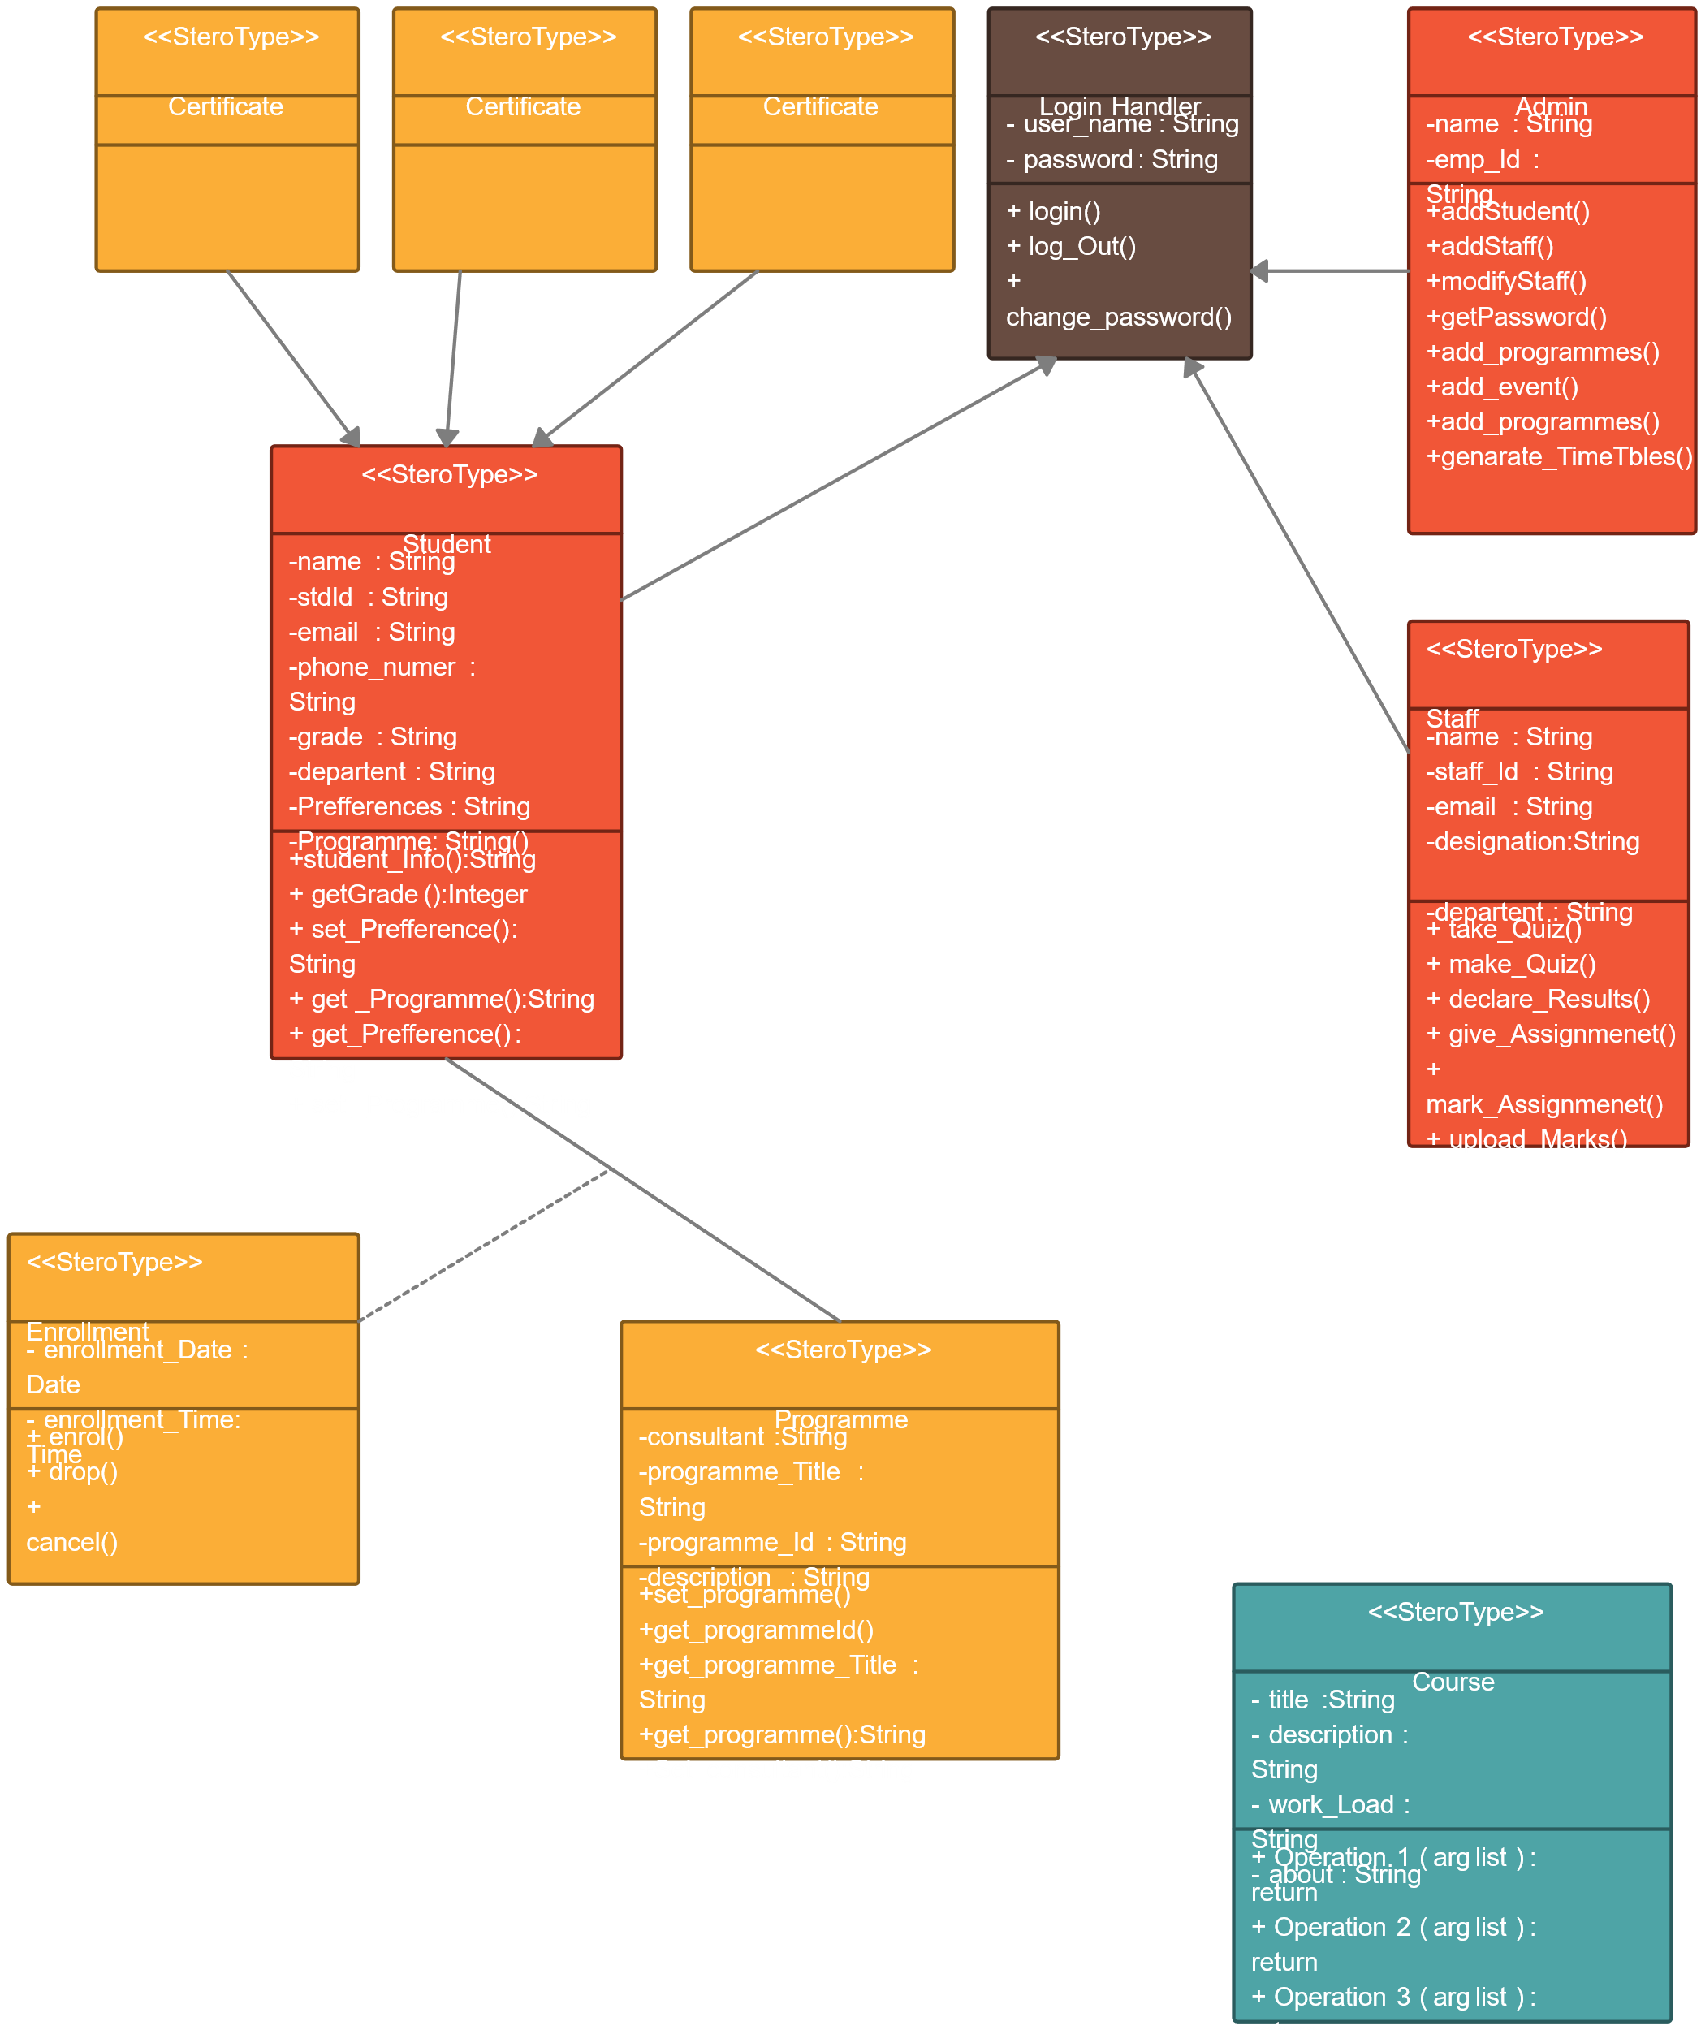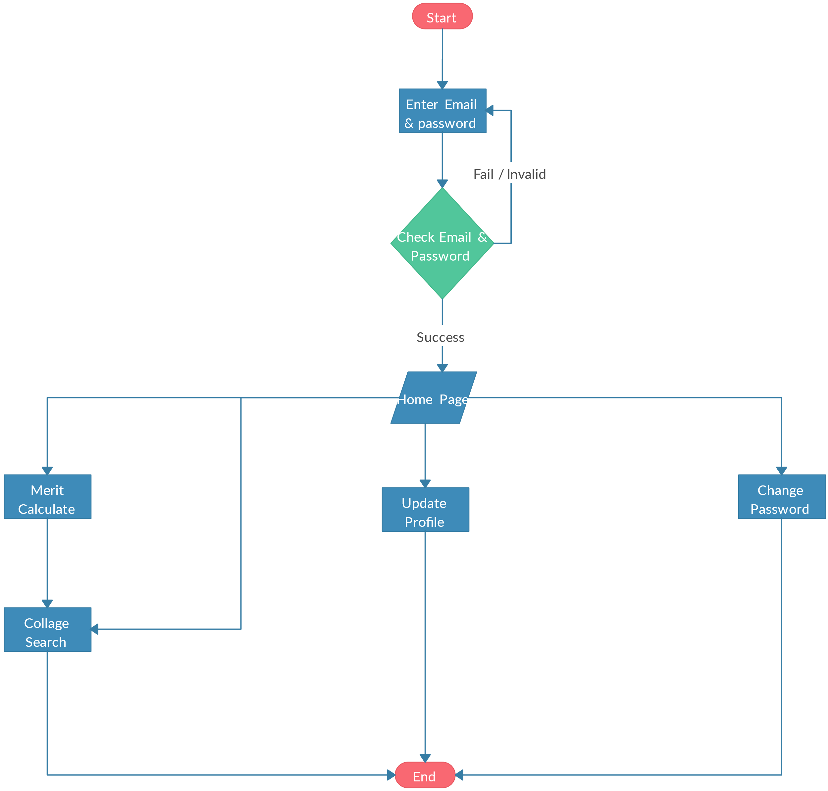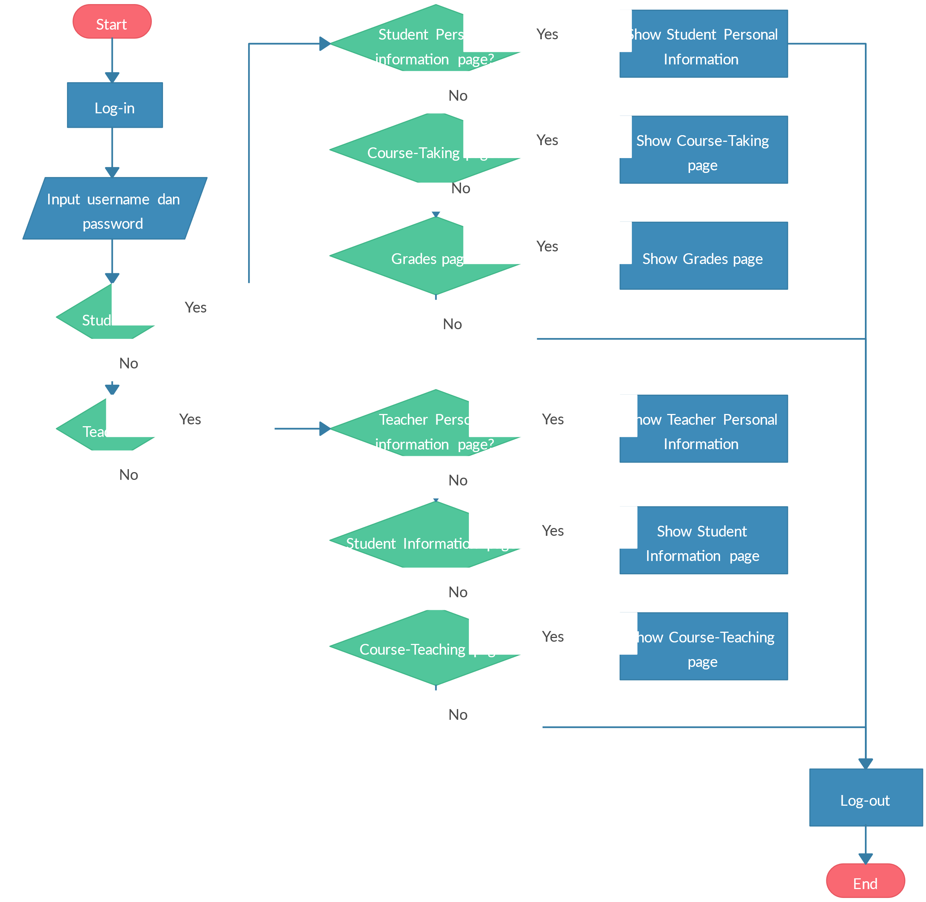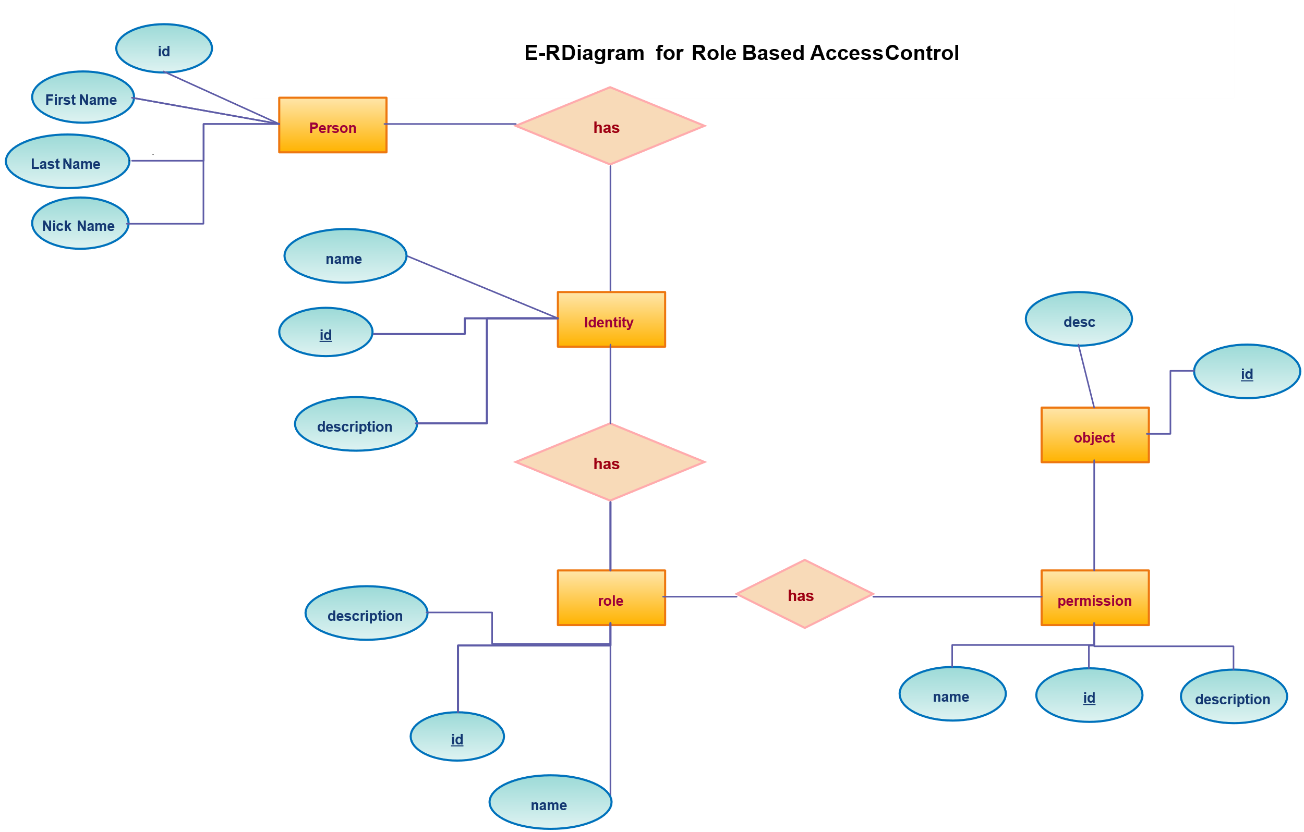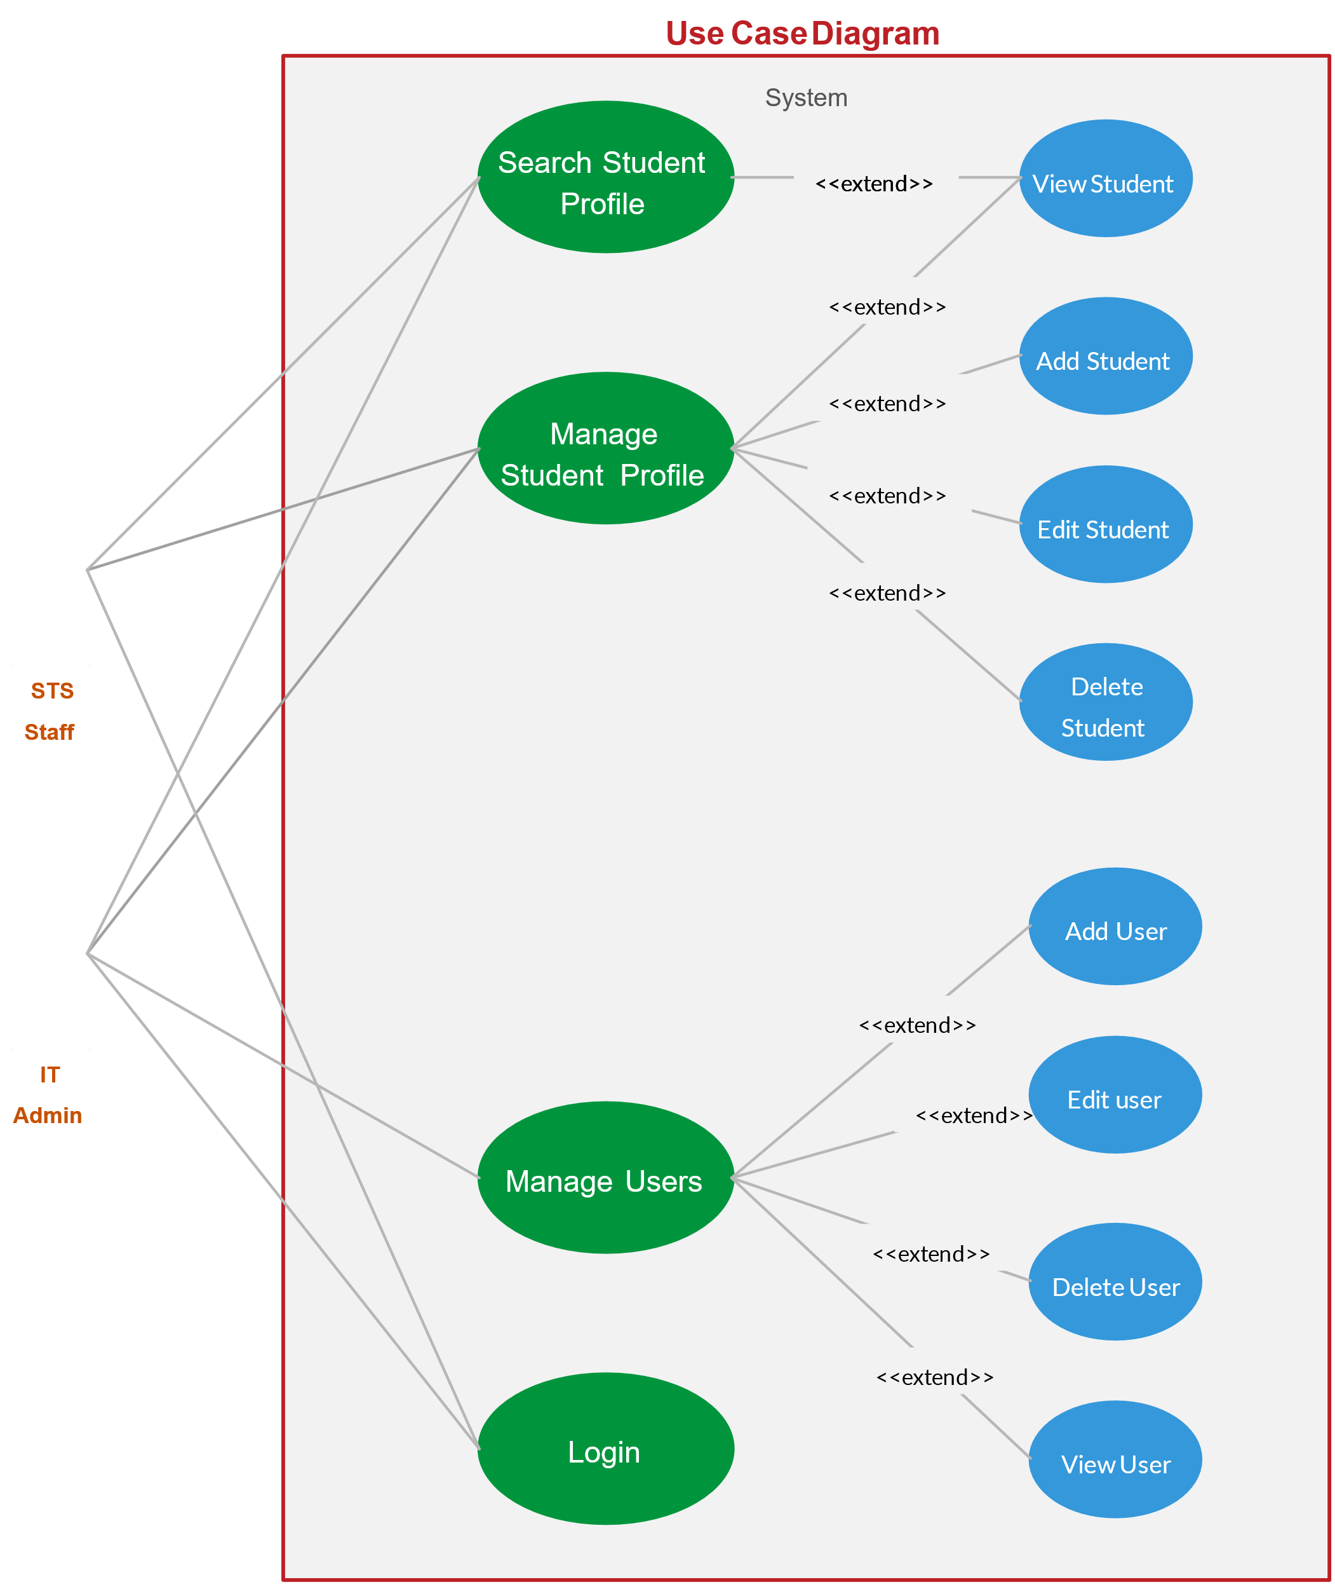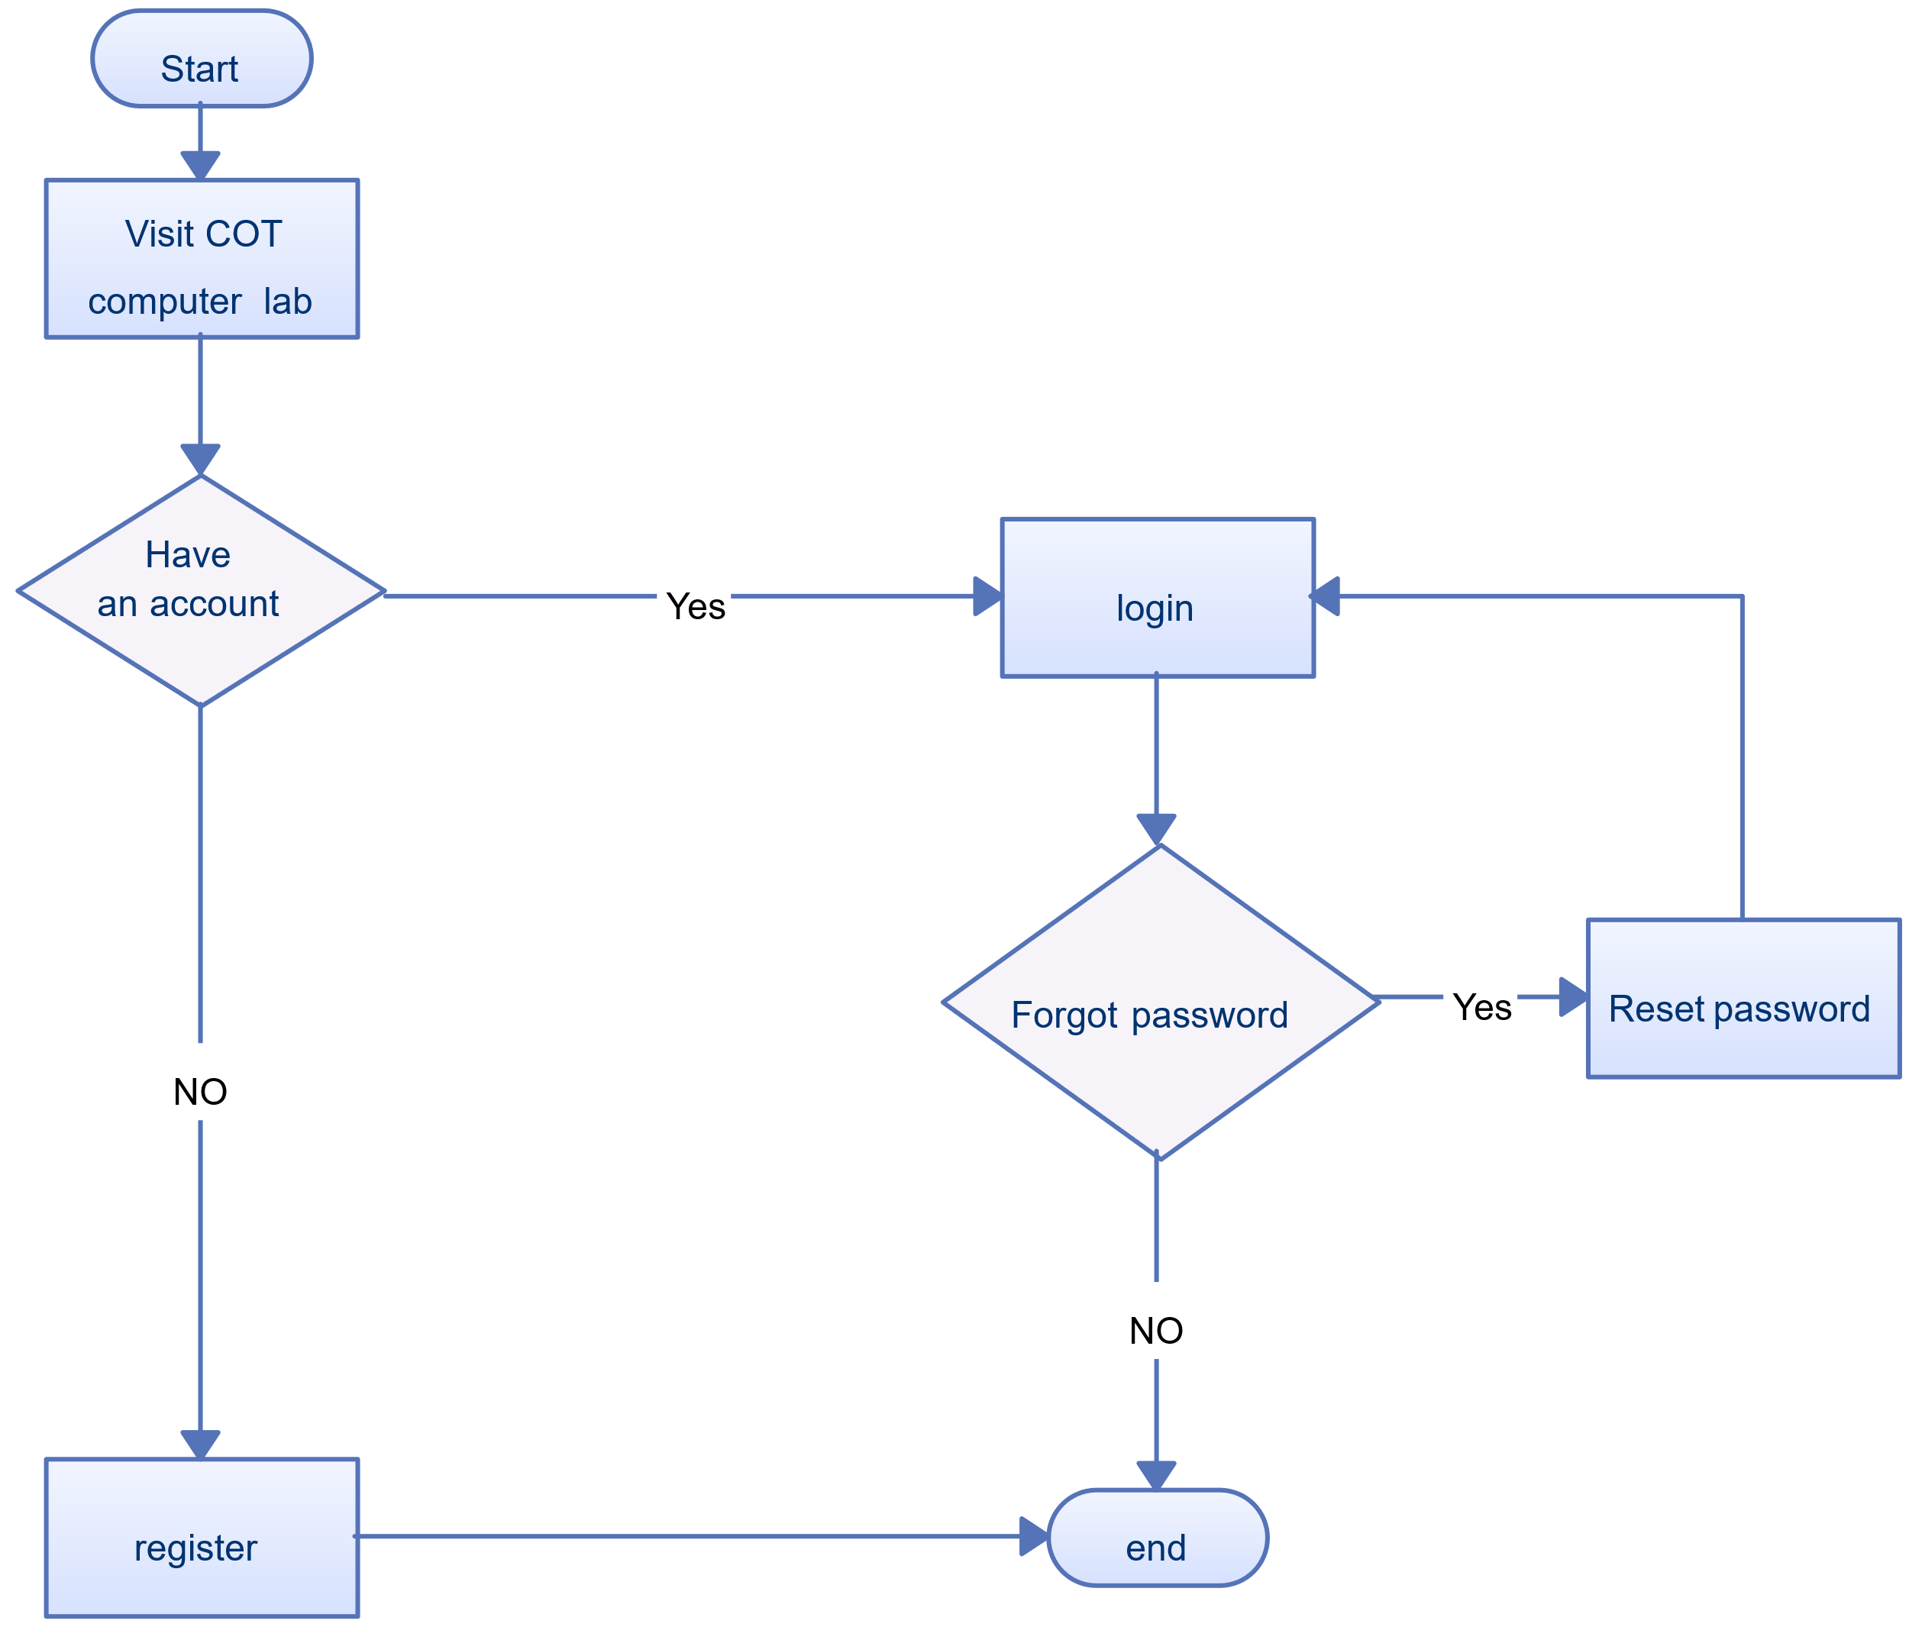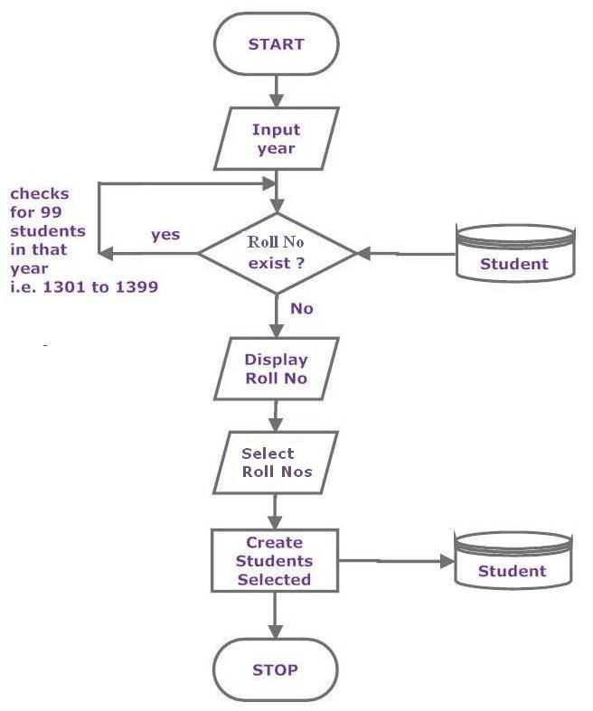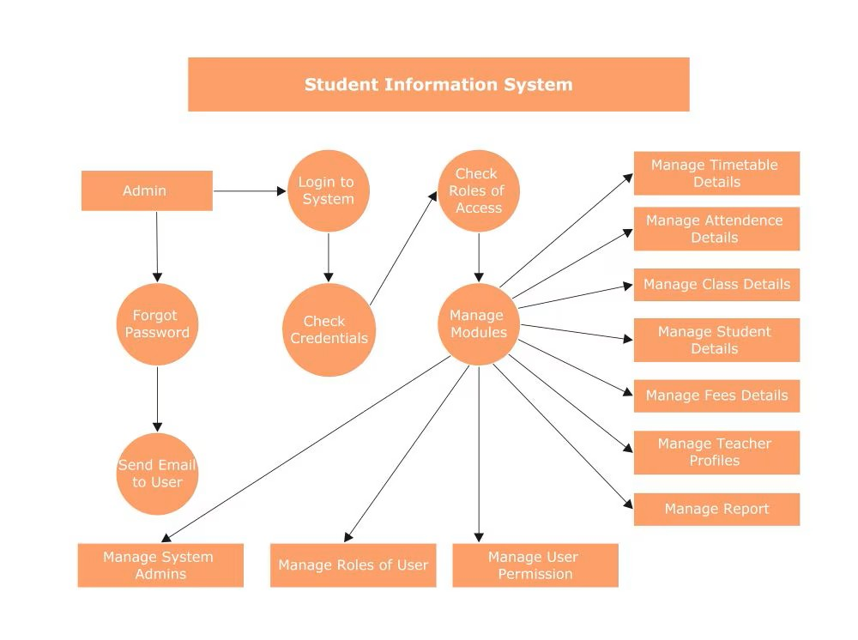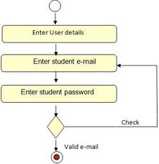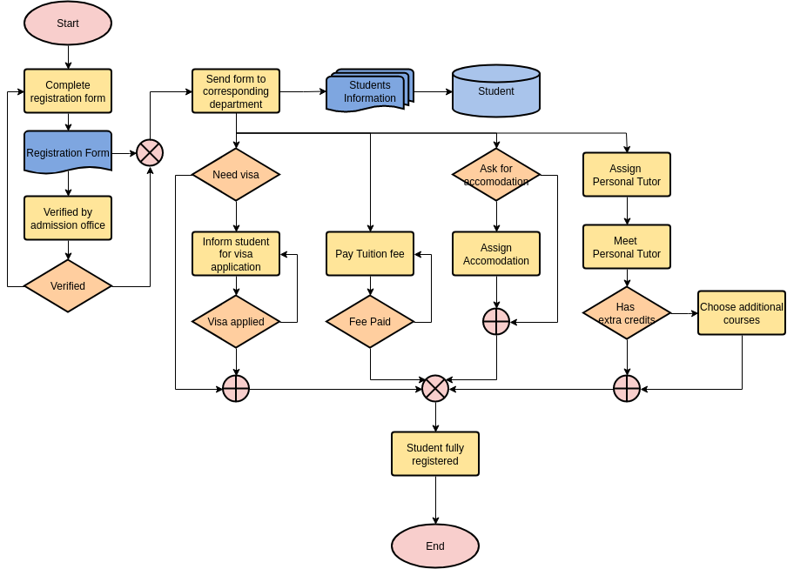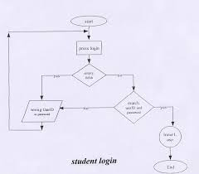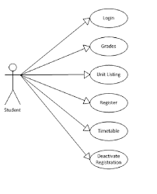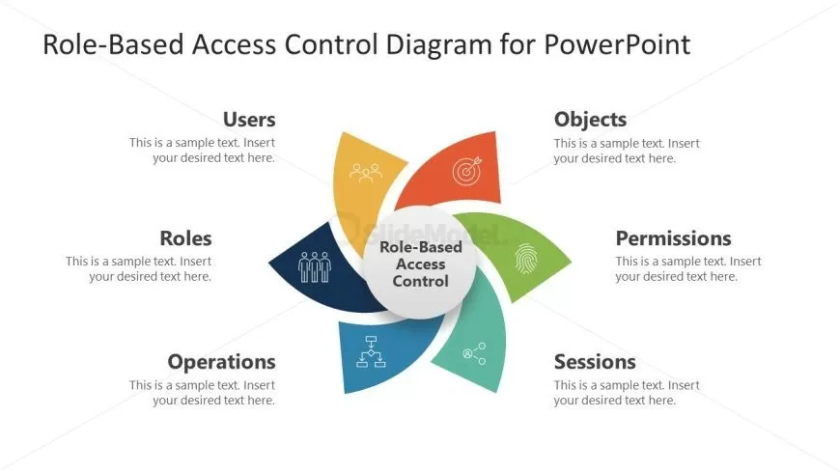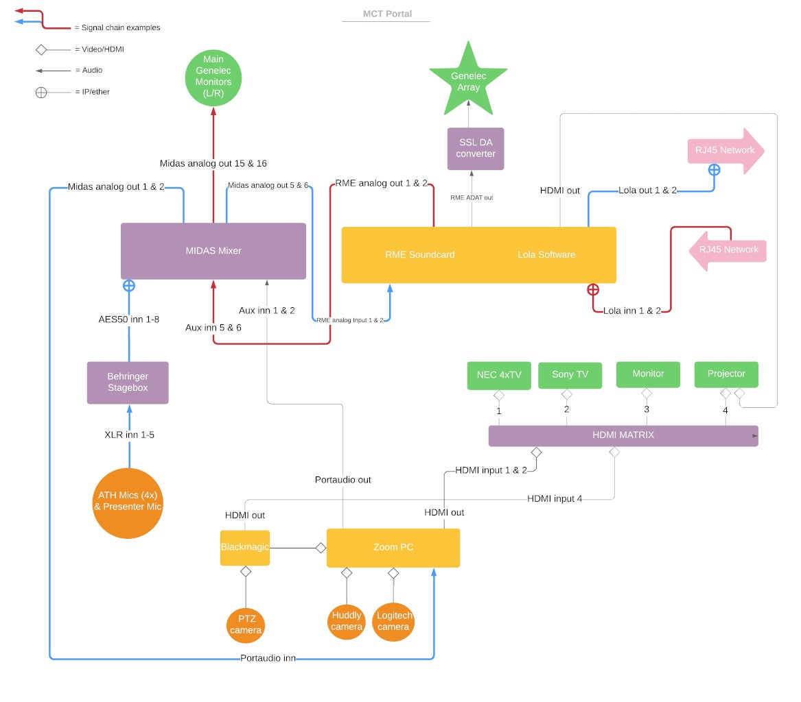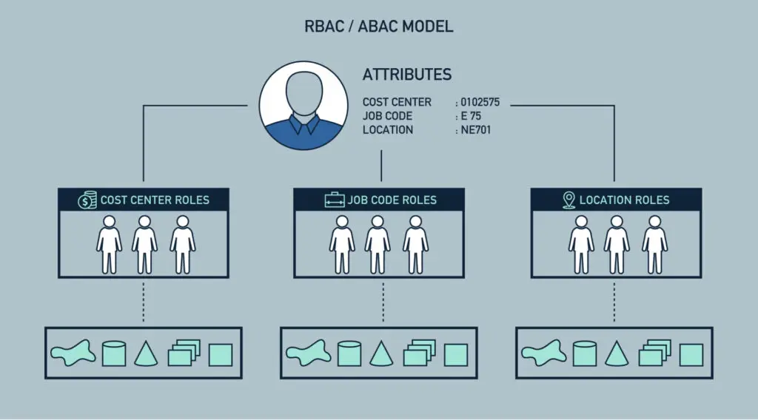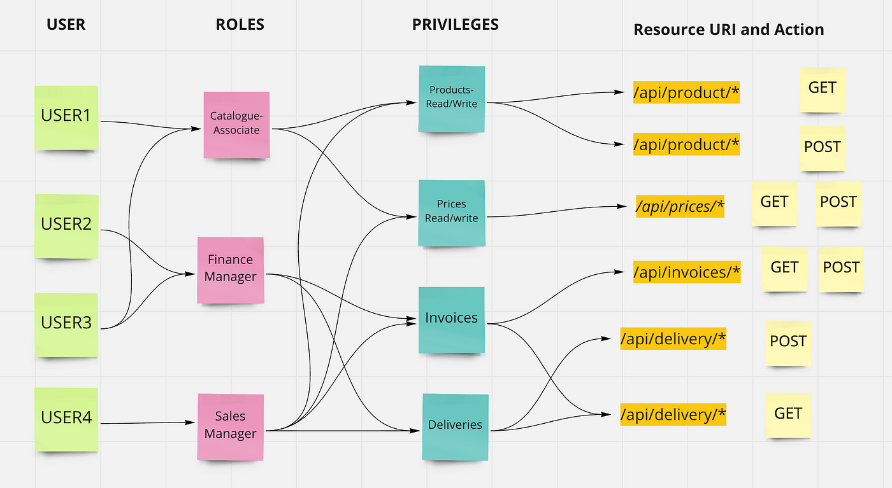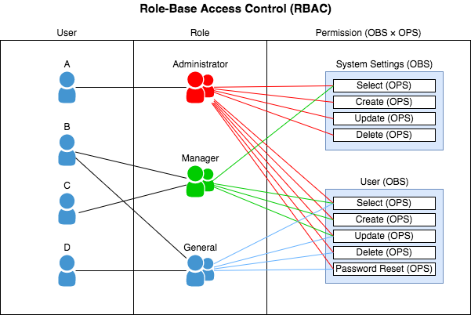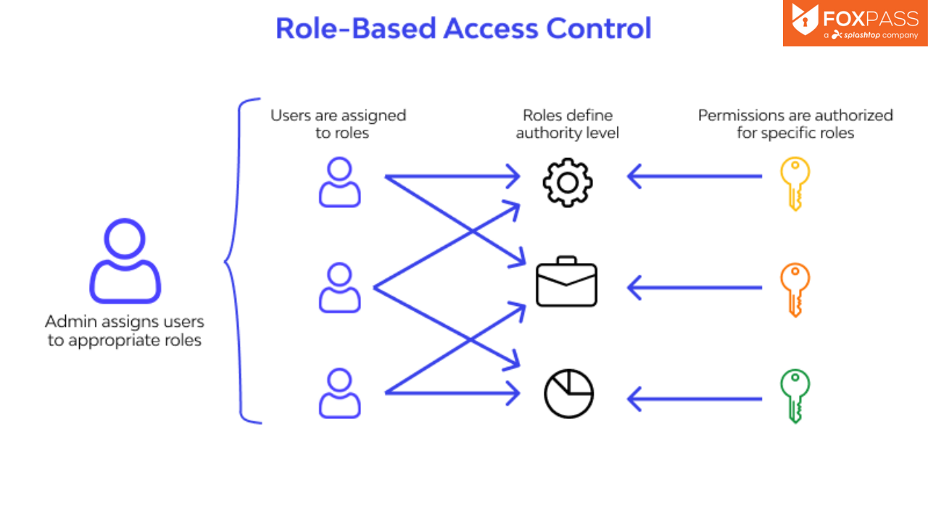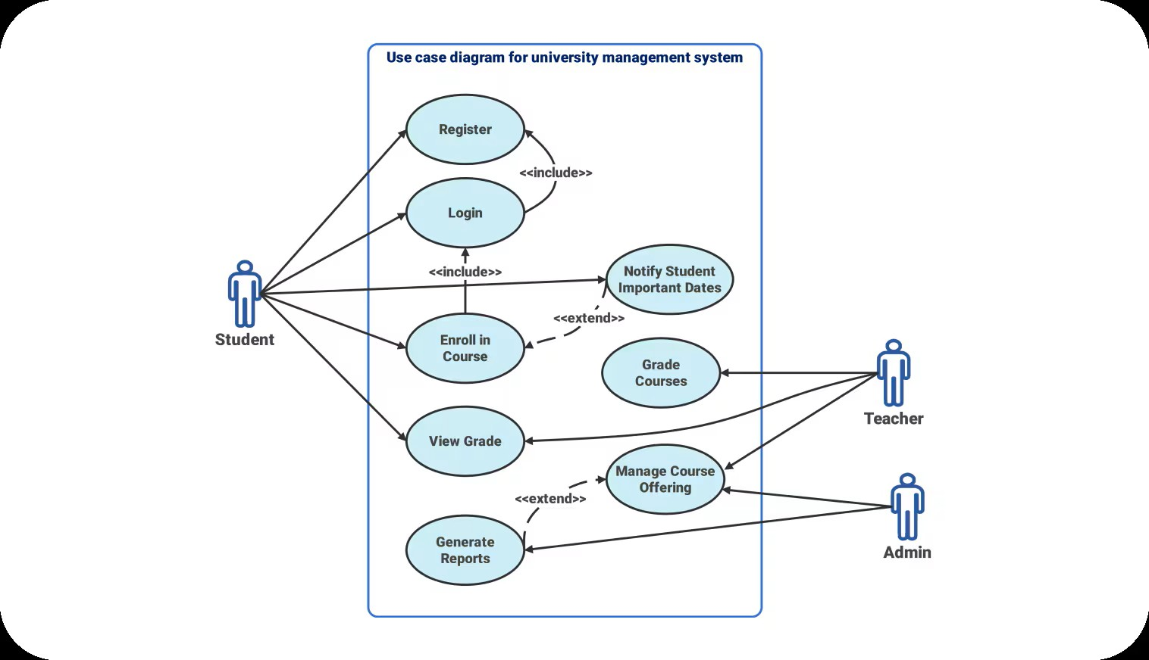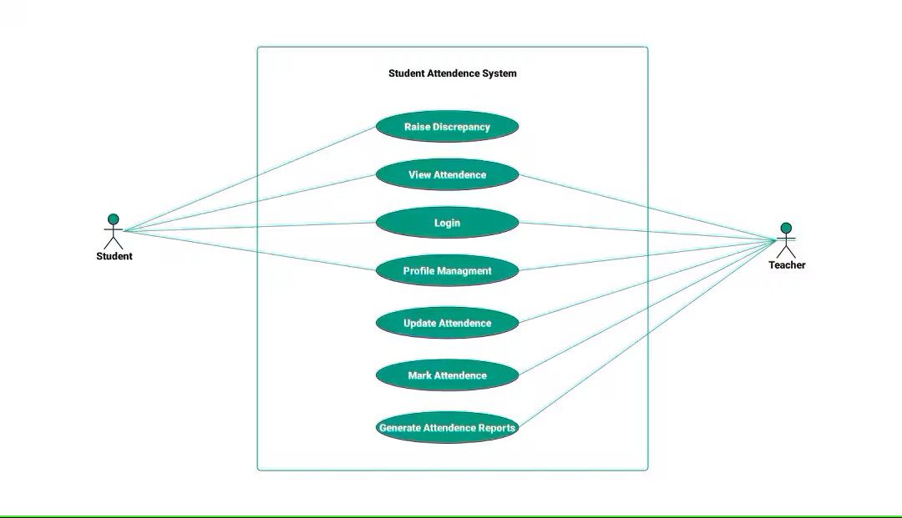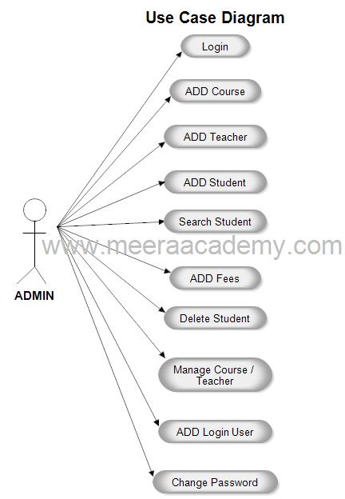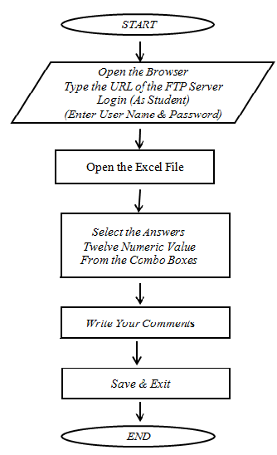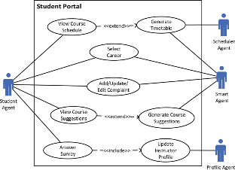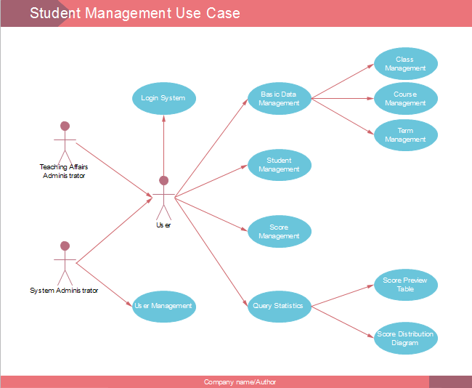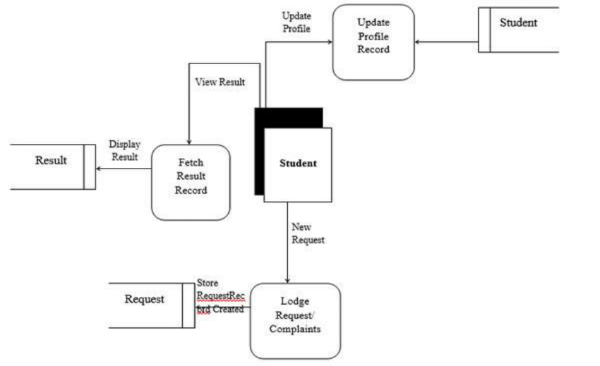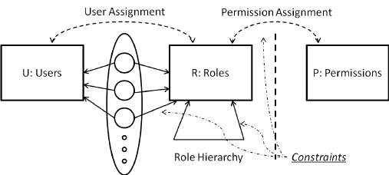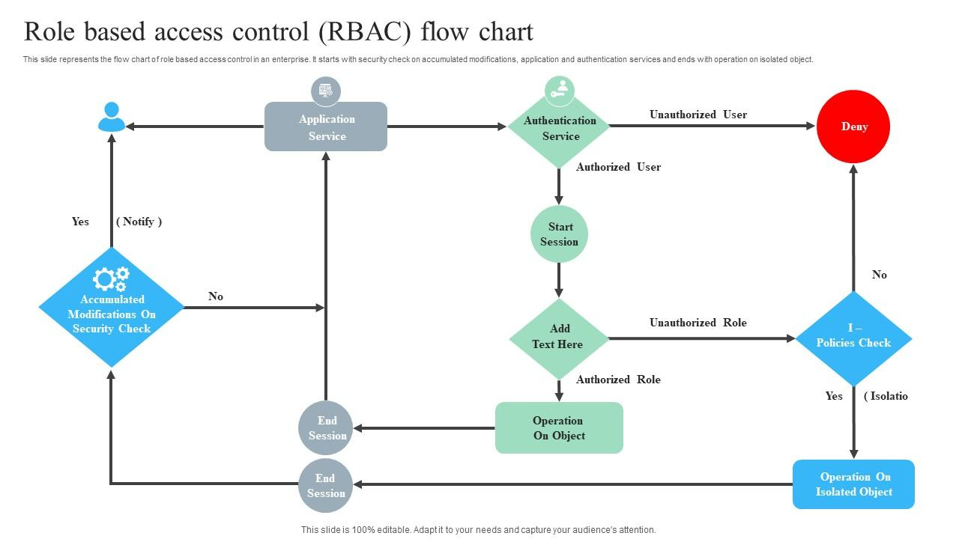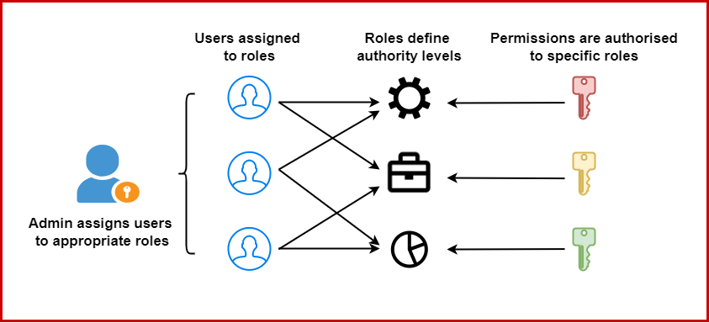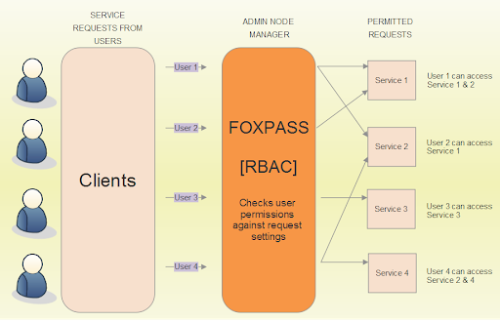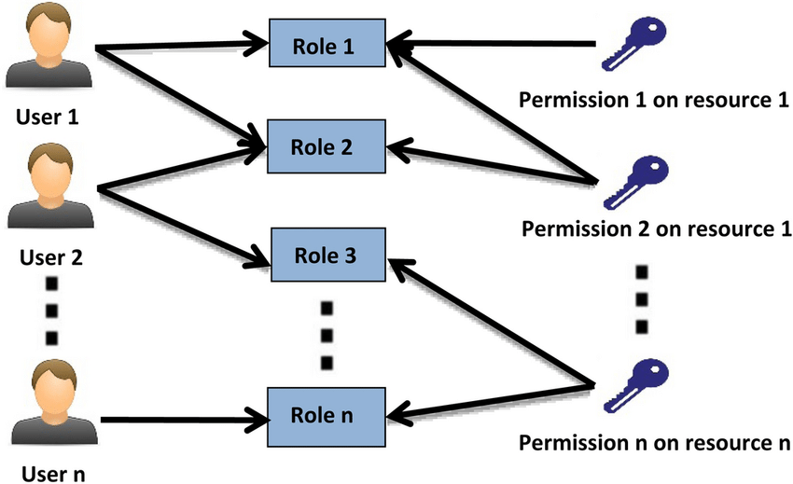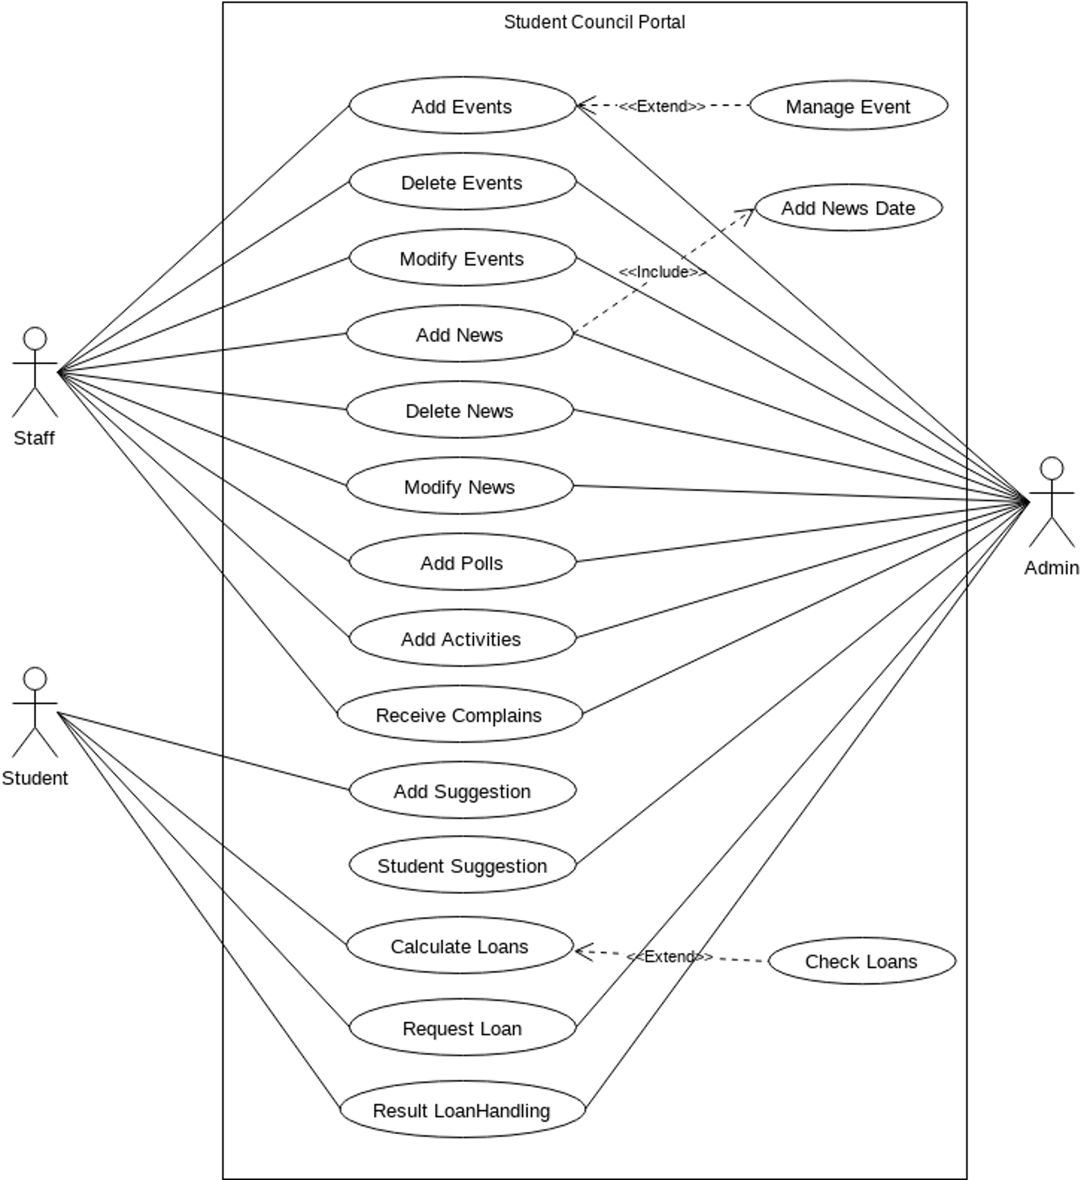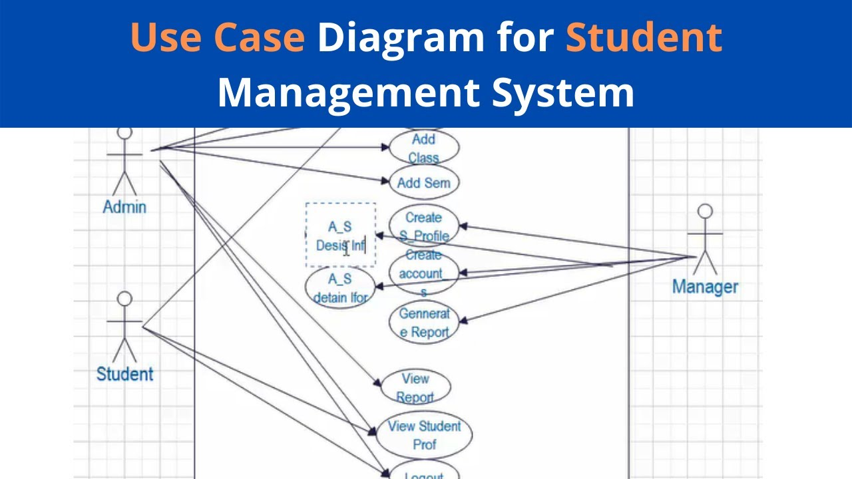

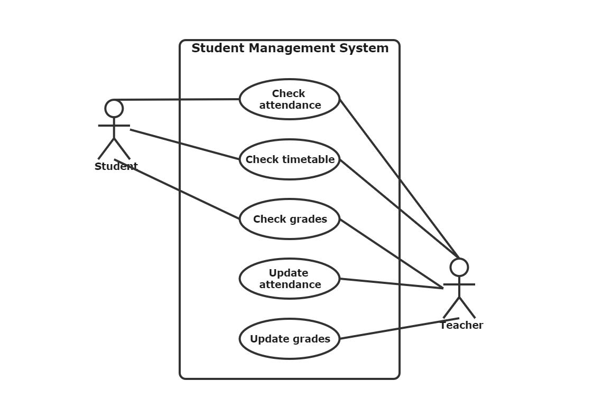

17. State Management

Redux vs. Context API Comparison

Both Redux and the Context API are tools for managing state in React applications, but they serve different purposes and are suited for different scenarios.

Redux:

* Centralized State Management: Redux provides a single source of truth for the application's state, making it easier to manage and debug complex state interactions.
* Middleware Support: Redux supports middleware like Redux Thunk and Redux Saga, which facilitate handling asynchronous actions and side effects.
* DevTools Integration: Redux DevTools offer powerful features for tracking state changes and debugging.
* Use Case: Ideal for large-scale applications with complex state logic and where state needs to be shared across many components.

Context API:

* Simplified State Sharing: The Context API allows for passing data through the component tree without having to pass props down manually at every level.Stack Overflow+2DEV Community+2DhiWise+2
* Less Boilerplate: Compared to Redux, the Context API requires less setup and code, making it quicker to implement for simpler state needs.DhiWise
* Use Case: Best suited for small to medium-sized applications or for sharing state that doesn't change frequently, such as theme or locale settings.

In summary, use the Context API for simpler state management needs and Redux for more complex, large-scale applications. GeeksforGeeks

Handling Asynchronous Data Fetching

Managing asynchronous data fetching is a common requirement in React applications. Here are some strategies:

1. Using `` with Fetch or Axios:

* The useEffect hook can be used to perform side effects, such as data fetching, after a component mounts.
* Fetch API or Axios can be used within useEffect to retrieve data from an API.

2. React Query or SWR:

* These libraries provide powerful tools for data fetching, caching, and updating the UI in response to data changes.
* They handle many aspects of data fetching out of the box, including caching, background updates, and request deduplication.

3. Redux Thunk or Redux Saga:

* When using Redux, middleware like Redux Thunk or Redux Saga can manage asynchronous actions, such as API calls, and dispatch actions based on the results.

4. Experimental `` API:

* React's experimental use API allows for suspending component rendering until a Promise resolves, simplifying asynchronous data handling. Medium

Optimizing State Updates

Efficient state updates are crucial for performance in React applications. Here are best practices:

1. Keep State Local Where Possible:

* Manage state within the component that needs it to avoid unnecessary re-renders of unrelated components.Medium

2. Use Memoization:

* Utilize React.memo to prevent re-rendering of components when props haven't changed.PixelFreeStudio Blog -
* Use useMemo and useCallback to memoize expensive computations and functions, respectively.DEV Community

3. Avoid Unnecessary State Updates:

* Only update state when necessary. Unneeded updates can lead to performance issues due to extra re-renders.

4. Split Components:

* Break down large components into smaller ones to isolate state and reduce the impact of re-renders. PixelFreeStudio Blog -

5. Use Selectors in Redux:

* When using Redux, selectors can help in retrieving specific slices of the state, reducing the amount of data a component depends on and minimizing re-renders.

By carefully choosing the appropriate state management tool, handling asynchronous data effectively, and optimizing state updates, you can build performant and maintainable React applications.

18. UI/UX Design Principles

Accessibility Best Practices

Ensuring digital accessibility is crucial for creating inclusive user experiences. Key practices include:

* Provide Sufficient Contrast: Ensure a contrast ratio of at least 4.5:1 between text and background to enhance readability for users with visual impairments.
* Avoid Color-Only Indicators: Don't rely solely on color to convey information; use text labels or patterns alongside colors to accommodate color-blind users. [W3C+1Lucid Software+1](https://www.w3.org/WAI/tips/designing/?utm_source=chatgpt.com)
* Ensure Keyboard Navigability: Design interfaces that are fully operable via keyboard, facilitating access for users with mobility challenges. WCAG
* Use Clear and Consistent Labels: Provide descriptive labels for form fields and interactive elements to assist users with screen readers. WCAG+2UX Collective+2Lucid Software+2
* Maintain Consistent Navigation: Keep navigation menus and interactive components consistent across pages to aid users with cognitive disabilities. UX Collective
* Offer Multiple Navigation Options: Provide various ways to locate content, such as search functions, menus, and site maps, to accommodate different user preferences.

Color Schemes and Typography Choices

Effective use of color and typography enhances usability and aesthetic appeal:

* Limit Color Palette: Use a cohesive palette of 5–7 colors to maintain visual harmony and avoid overwhelming users. Medium
* Establish Visual Hierarchy: Utilize color contrast and typography to guide users' attention to key elements.
* Choose Readable Fonts: Select legible typefaces and maintain appropriate font sizes and line spacing to enhance readability.
* Apply Consistent Typography: Use consistent font styles and sizes across the application to create a unified look and feel.
* Use Color to Convey Meaning: Assign specific colors to represent different states (e.g., red for errors, green for success) to provide intuitive feedback. Elinext

User Feedback Incorporation

Integrating user feedback is vital for iterative design improvements:UXPin+1arxiv.org+1

* Gather Feedback Early and Often: Collect user input throughout the design process to identify issues and preferences.
* Utilize Multiple Feedback Channels: Employ surveys, interviews, usability tests, and analytics to gather comprehensive insights.
* Analyze and Prioritize Feedback: Assess feedback to identify common themes and prioritize changes that will have the most significant impact.
* Implement Feedback Responsively: Make iterative design changes based on user input and communicate updates to users to show that their feedback is valued.
* Test Changes with Users: After implementing feedback, conduct further testing to ensure that changes effectively address user needs.

By adhering to these principles, designers can create user interfaces that are accessible, aesthetically pleasing, and responsive to user needs, resulting in a more inclusive and satisfying user experience.

19. Accessibility Considerations

WCAG Compliance Strategies

The Web Content Accessibility Guidelines (WCAG) 2.1, developed by the W3C, provide a framework to make web content more accessible to individuals with disabilities. These guidelines are structured around four core principles:[Nucamp+3W3C+3W3C+3](https://www.w3.org/TR/WCAG21/?utm_source=chatgpt.com)

* Perceivable: Information and user interface components must be presentable to users in ways they can perceive.
* Operable: User interface components and navigation must be operable.
* Understandable: Information and the operation of the user interface must be understandable.AudioEye
* Robust: Content must be robust enough to be interpreted reliably by a wide variety of user agents, including assistive technologies.

To align with WCAG 2.1 standards:

* Use Semantic HTML: Employ appropriate HTML elements (e.g., <header>, <nav>, <main>, <footer>) to define the structure of your content, aiding assistive technologies in interpreting the page correctly.
* Ensure Sufficient Color Contrast: Maintain a contrast ratio of at least 4.5:1 between text and background to enhance readability for users with visual impairments.
* Provide Text Alternatives: Include descriptive alt attributes for images and ensure that all non-text content has a text alternative.
* Design Responsive Interfaces: Create layouts that adapt to various screen sizes and orientations, facilitating access on different devices.
* Implement Accessible Forms: Label form controls clearly, provide instructions, and ensure error messages are descriptive and programmatically associated with the relevant fields.

For detailed guidelines, refer to the [Web Content Accessibility Guidelines (WCAG) 2.1](https://www.w3.org/TR/WCAG21/).[W3C+1Wikipedia+1](https://www.w3.org/TR/WCAG21/?utm_source=chatgpt.com)

Keyboard Navigation and Screen Reader Support

Ensuring that your application is navigable via keyboard and compatible with screen readers is vital for users with motor and visual impairments.

Keyboard Navigation:

* Logical Tab Order: Arrange interactive elements in a sequence that follows the visual flow of the page, typically from top to bottom and left to right.WebAIM
* Visible Focus Indicators: Ensure that the element in focus is visually distinguishable, aiding users in tracking their navigation.
* Skip Links: Provide options to skip repetitive content, allowing users to navigate directly to the main content.
* Accessible Custom Controls: When creating custom interactive components, ensure they are operable via keyboard and include appropriate ARIA roles and properties.WebAIM

For comprehensive guidance, consult WebAIM's Keyboard Accessibility.WebAIM+1W3C+1

Screen Reader Support:

* Use ARIA Landmarks: Implement ARIA roles (e.g., role="navigation", role="main") to define regions of the page, assisting screen reader users in understanding the layout.
* Descriptive Link Text: Ensure that link text conveys the purpose of the link, avoiding vague phrases like "click here."
* Proper Heading Structure: Use heading tags (<h1> to <h6>) to establish a clear content hierarchy, enabling screen reader users to navigate efficiently.
* Label Form Elements: Associate labels with form controls using the for attribute, ensuring screen readers can announce them correctly.

For more information, refer to [W3C's Designing for Web Accessibility](https://www.w3.org/WAI/tips/designing/).[W3C+4W3C+4W3C+4](https://www.w3.org/WAI/tips/designing/?utm_source=chatgpt.com)

Testing Accessibility Features

Regular testing is essential to identify and rectify accessibility issues. Employ both automated and manual testing methods:

Automated Testing Tools:

* Axe: An accessibility engine for automated testing of web applications.
* Lighthouse: An open-source tool integrated into Chrome DevTools for auditing accessibility, performance, and more.
* WAVE: A suite of evaluation tools to help authors make their web content more accessible.[W3C+1W3C+1](https://www.w3.org/TR/WCAG21/?utm_source=chatgpt.com)

While automated tools can identify many issues, they cannot catch all accessibility problems.

Manual Testing:

* Keyboard Testing: Navigate your application using only the keyboard (e.g., Tab, Shift+Tab, Enter) to ensure all interactive elements are accessible.
* Screen Reader Testing: Use screen readers like NVDA (Windows) or VoiceOver (macOS) to experience your application from the perspective of users who rely on these tools.ETR
* User Testing: Engage users with disabilities to test your application and provide feedback on its accessibility.

For a detailed approach to manual testing, consider [Harvard's Manual Testing for Accessibility](https://accessibility.huit.harvard.edu/manual-testing-accessibility).[Harvard Accessibility+1accessibility.web-resources.upenn.edu+1](https://accessibility.huit.harvard.edu/manual-testing-accessibility?utm_source=chatgpt.com)

By implementing these strategies, you can enhance the accessibility of your application, ensuring it is usable by a broader audience and compliant with established guidelines.

20. Performance Optimization

Lazy Loading and Code Splitting

Lazy Loading: This technique delays the loading of non-critical resources until they are needed, reducing initial load times. In React, you can implement lazy loading using React.lazy and Suspense:Medium

jsx

CopyEdit

const LazyComponent = React.lazy(() => import('./LazyComponent')); function App() { return ( <div> <Suspense fallback={<div>Loading...</div>}> <LazyComponent /> </Suspense> </div> ); }

This approach ensures that LazyComponent is only loaded when it's rendered, improving performance by reducing the initial bundle size. LinkedIn+3Medium+3LoadForge+3

Code Splitting: Code splitting divides your code into smaller chunks, which can be loaded on demand. In Next.js, dynamic imports facilitate code splitting:Medium+1StudyRaid+1StudyRaid+3GreatFrontEnd+3JavaScript in Plain English+3

jsx

CopyEdit

import dynamic from 'next/dynamic'; const DynamicComponent = dynamic(() => import('./DynamicComponent')); function Page() { return <DynamicComponent />; }

This method loads DynamicComponent only when it's needed, enhancing load times and user experience. LinkedIn+3Medium+3LoadForge+3

Database Query Optimization

Efficient database queries are vital for application performance. Here are some best practices:

* Use Proper Indexing: Indexes speed up data retrieval. Ensure that columns used in WHERE clauses and joins are indexed appropriately. Developer Nation+1GeeksforGeeks+1
* **Avoid SELECT ***: Retrieve only the necessary columns to reduce data transfer and processing time.
* Limit Data Retrieval: Use LIMIT clauses to fetch only the required number of rows, preventing unnecessary data loading. DataCamp
* Optimize Joins: Choose the most efficient join types and ensure that joined columns are indexed. Analyze query execution plans to identify and resolve bottlenecks. Monte Carlo Data+1Reddit+1
* Avoid Queries Inside Loops: Executing queries within loops can lead to performance issues. Instead, batch operations when possible. GeeksforGeeks

Frontend Rendering Improvements

Enhancing frontend rendering leads to smoother user interactions:

* Minimize Repaints and Reflows: Structure your CSS and DOM to reduce layout thrashing. Avoid inline styles that can trigger reflows.
* Optimize Images: Use appropriately sized images and modern formats like WebP. Implement lazy loading for images to defer loading until they're in the viewport.
* Use Efficient CSS and JavaScript: Minify and compress CSS and JS files. Remove unused code and leverage tree-shaking to eliminate dead code.
* Implement Server-Side Rendering (SSR): SSR can improve initial load times and SEO by rendering pages on the server. Next.js supports SSR out of the box.[arXiv](https://arxiv.org/abs/2504.03884?utm_source=chatgpt.com)
* Monitor Performance: Utilize tools like Lighthouse and Chrome DevTools to analyze and monitor performance metrics, identifying areas for improvement.

By incorporating these strategies, you can significantly enhance the performance of your application, leading to better user engagement and satisfaction.

21. Testing Strategies

Unit, Integration, and End-to-End Testing

A well-structured testing pyramid ensures comprehensive coverage:

* Unit Testing: Focuses on individual components or functions in isolation. These tests are fast, easy to write, and help catch bugs early in the development cycle.
* Integration Testing: Validates the interaction between multiple components or systems, ensuring they work together as intended. This helps identify issues arising from component interactions.
* End-to-End (E2E) Testing: Simulates real user scenarios to test the complete application flow, from start to finish. E2E tests are crucial for verifying that the system meets business requirements and user expectations. CircleCI

Implementing a balanced mix of these tests enhances software reliability and maintainability.

Automated Testing Tools

Leveraging automated testing tools accelerates the testing process and improves accuracy. Popular tools include:

* Selenium: An open-source framework for automating web browsers, supporting multiple languages and browsers. WIRED
* Playwright: A Node.js library by Microsoft for automating Chromium, Firefox, and WebKit browsers with a single API. It supports multiple languages and is known for its reliability and speed. Playwright
* Cypress: A JavaScript end-to-end testing framework that operates directly in the browser, offering fast and reliable testing for modern web applications.Playwright
* TestCafe: A Node.js-based tool that allows for end-to-end testing without the need for browser plugins, supporting JavaScript and TypeScript. BrowserStack
* Rainforest QA: A no-code platform enabling non-technical users to create and manage automated tests, facilitating broader team involvement in the testing process.

Selecting the appropriate tool depends on the project's specific requirements, team expertise, and the desired level of test automation.

Test-Driven Development (TDD) Approach

TDD is a development methodology where tests are written before the actual code. The cycle typically follows:[ACCELQ+2Wikipedia+2ConformIQ+2](https://en.wikipedia.org/wiki/Test-driven_development?utm_source=chatgpt.com)

1. Write a Test: Define a test for a new function or feature.
2. Run the Test: Initially, the test should fail since the feature isn't implemented yet.
3. Write Code: Develop the minimum code necessary to pass the test.
4. Run Tests: Ensure all tests pass.
5. Refactor: Optimize the code while keeping tests green.

Benefits of TDD:

* Improved Code Quality: By focusing on test cases first, developers produce more reliable and error-resistant code.[Wikipedia](https://en.wikipedia.org/wiki/Test-driven_development?utm_source=chatgpt.com)
* Faster Debugging: Early detection of issues reduces the time spent on debugging later in the development cycle.
* Better Software Design: TDD encourages modular and well-structured code, facilitating easier maintenance and scalability.ACCELQ
* Increased Maintainability: A comprehensive test suite ensures that future changes don't break existing functionality.

Adopting TDD can lead to more predictable development outcomes and a higher level of confidence in the codebase.

Implementing a combination of these testing strategies, supported by appropriate tools and methodologies like TDD, can significantly enhance the quality and reliability of software applications.

22. CI/CD Pipeline

GitHub Actions vs. Jenkins: A Comparative Analysis

|  |  |  |
| --- | --- | --- |
| FeatureGitHub ActionsJenkins |  |  |
| Hosting Model | Cloud-based with optional self-hosted runners | Self-hosted, requiring manual setup and maintenance |
| Integration | Seamless integration with GitHub repositories | Supports various VCS providers (GitHub, GitLab, Bitbucket, etc.) |
| Configuration Language | YAML | Groovy (via Jenkinsfile) |
| Ease of Setup | Minimal setup; ready to use within GitHub environment | Requires installation, configuration, and plugin management |
| Extensibility | Extensive marketplace with reusable actions | Vast plugin ecosystem for diverse functionalities |
| Scalability | Automatically scales with GitHub infrastructure | Manual scaling; dependent on self-managed resources |
| Community Support | Growing community with active contributions | Mature community with extensive documentation and support |

GitHub Actions is ideal for teams already utilizing GitHub, offering a streamlined experience with minimal overhead. Its tight integration simplifies the CI/CD process, making it suitable for small to medium-sized projects. However, it may present limitations in complex, multi-repository environments due to challenges in centralized management and coordination .Northflank

Jenkins, being a long-standing CI/CD tool, provides extensive customization and flexibility, accommodating complex workflows and diverse project requirements. It is well-suited for larger organizations with dedicated DevOps teams capable of managing its setup and maintenance .[LinkedIn](https://www.linkedin.com/pulse/jenkins-vs-github-actions-which-cicd-tool-right-you-humphrey-ikhalea-an2xf?utm_source=chatgpt.com)

Deployment Automation Strategies

Effective deployment automation enhances reliability and accelerates the release process. Key strategies include:

* Infrastructure as Code (IaC): Utilize tools like Terraform or Ansible to define and manage infrastructure, ensuring consistency across environments.
* Automated Testing: Integrate unit, integration, and end-to-end tests within the pipeline to catch issues early.
* Continuous Deployment: Automate the release process to deploy code changes to production automatically after passing all tests, reducing manual intervention.
* Monitoring and Logging: Implement comprehensive monitoring to track application performance and detect anomalies post-deployment.AppMaster

Rollback Strategies

Implementing robust rollback mechanisms is crucial to mitigate the impact of faulty deployments. Effective strategies include:

* Blue-Green Deployments: Maintain two identical environments (blue and green); deploy new versions to the inactive one and switch traffic upon successful validation, allowing easy rollback if issues arise .Medium
* Canary Releases: Gradually roll out changes to a subset of users, monitoring for issues before a full-scale deployment.
* Feature Toggles: Implement feature flags to enable or disable features without deploying new code, facilitating quick rollbacks.
* Immutable Infrastructure: Deploy new instances with the updated code rather than modifying existing ones, allowing easy reversion by switching back to previous instances.
* Automated Rollbacks: Configure the CI/CD pipeline to automatically revert to the last stable version upon detecting failures or anomalies during deployment .Medium+1Essential Designs+1

By carefully selecting the appropriate CI/CD tools and implementing strategic deployment and rollback mechanisms, organizations can enhance their software delivery processes, ensuring stability, scalability, and rapid recovery from potential issues.

23. Deployment Strategy

Vercel vs. Render vs. Heroku: Platform Comparison

|  |  |  |  |
| --- | --- | --- | --- |
| FeatureVercelRenderHeroku |  |  |  |
| Ideal Use Case | Frontend frameworks (e.g., Next.js), static sites | Full-stack apps, APIs, background workers | General-purpose apps, prototypes, multi-language support |
| Hosting Model | Serverless (CDN + edge functions) | Container-based (Docker or native) | Dyno-based (ephemeral containers) |
| CI/CD Integration | Built-in with GitHub/GitLab/Bitbucket | Built-in with GitHub/GitLab/Bitbucket | Built-in with GitHub/GitLab/Bitbucket |
| Zero-Downtime Deploys | Yes, via atomic deployments | Yes, except when using persistent disks | Yes, via preboot feature |
| Environment Variable Management | UI & CLI support; per environment | UI, CLI, and render.yaml support | UI, CLI, and config vars |
| Pricing | Free tier with limits; usage-based pricing | Free tier with generous limits; competitive pricing | Free tier (limited); pricing can escalate with scale |
| Custom Domains & SSL | Automatic SSL; easy custom domain setup | Automatic SSL; custom domains supported | Automatic SSL; custom domains supported |
| Rollback Support | Manual via redeploying previous commits | Instant rollbacks to any version | Rollbacks via release management |

Vercel excels in deploying frontend applications, especially those built with Next.js, offering seamless integration and global CDN distribution. Render provides a versatile platform suitable for full-stack applications, APIs, and background workers, with features like SSD-based storage and private networking. Heroku offers a mature platform with extensive language support and a robust add-on ecosystem, making it suitable for a wide range of applications. RenderRitza

Environment Variable Management

Managing environment variables is crucial for configuring applications across different environments:

* Vercel: Offers UI and CLI support for setting environment variables, allowing configuration per environment (development, preview, production).
* Render: Supports environment variables through its dashboard, CLI, and render.yaml configuration files, facilitating version control and reproducibility.
* Heroku: Provides environment variable management via its dashboard and CLI (heroku config), with support for different environments through pipelines and staging apps.

Zero-Downtime Deployment Techniques

Ensuring zero-downtime during deployments is vital for maintaining application availability:

* Vercel: Utilizes atomic deployments, where new deployments are built and validated before switching traffic, ensuring uninterrupted service.
* Render: Performs zero-downtime deploys by creating a new instance of the service and routing traffic to it only after it passes health checks. However, when using persistent disks, zero-downtime deploys are not supported due to the risk of data corruption. Render+1Render+1Reddit+4Railway Help Station+4Render+4
* Heroku: Offers a "preboot" feature that keeps the old version running until the new one is ready, minimizing downtime during deployments.

By understanding the strengths and limitations of each platform, along with effective environment variable management and deployment strategies, you can choose the most suitable deployment approach for your application's needs.

25. Error Handling

* Logging and Monitoring Errors  
  To ensure that errors are efficiently handled in a production environment, it’s important to use logging systems. Logging tools like Winston or Morgan in Node.js can be used to capture server-side errors. Logs should contain information such as timestamps, error severity levels, and stack traces. By integrating centralized logging systems such as ELK (Elasticsearch, Logstash, Kibana) or Datadog, the application can effectively monitor and analyze the errors.
* User-friendly Error Messages  
  In a user-facing application, errors should be communicated in a way that is not overwhelming or cryptic. Avoid exposing stack traces or sensitive information to the user. Instead, opt for clear and concise error messages that direct users to take appropriate action. An example is: "Something went wrong. Please try again later."
* Debugging Techniques  
  Debugging is a crucial part of development. Use tools like Node.js's built-in debugger, VSCode's debugger, or Chrome DevTools to identify issues in your code. Additionally, debugging libraries such as debug or loglevel can provide more flexible logging mechanisms with various logging levels like debug, info, and error.

26. Monitoring and Logging

* Tools like Prometheus and Grafana  
  Prometheus is widely used for monitoring the performance of systems. It collects and stores time-series data, such as system metrics (CPU, memory usage). Grafana can then visualize this data in real-time with custom dashboards. These tools are crucial for maintaining uptime and ensuring the application’s smooth operation in production environments.
* Log Aggregation Strategies  
  A log aggregation strategy involves collecting logs from various sources (e.g., servers, databases, microservices) and centralizing them for easier monitoring and analysis. Tools like Loggly, Splunk, and ELK (Elasticsearch, Logstash, Kibana) can help in aggregating and searching logs efficiently.
* Real-Time Monitoring Dashboards  
  Real-time dashboards allow you to monitor the health of your application as it runs. Grafana or Datadog can be used to build dashboards that display metrics like response times, error rates, and system load, enabling proactive issue resolution.

27. Database Management

* Backup and Recovery Strategies  
  Regular backups are essential for data integrity and disaster recovery. Automating backups using tools like MongoDB Atlas backups or creating custom scripts for scheduled backups is a good strategy. Ensure that backup files are stored securely in separate locations (e.g., cloud storage, external hard drives). For recovery, you should define the process to restore backups to minimize downtime.
* Schema Evolution Techniques  
  In the course of the development lifecycle, database schemas may need to evolve (e.g., adding fields or changing data types). It's important to handle schema changes in a way that does not break existing functionality. Mongoose provides built-in methods for schema migrations, and schema versioning helps track changes in the database schema.
* Handling Large Datasets Efficiently  
  Large datasets can be challenging to manage. Techniques like sharding (splitting data into smaller chunks) and indexing (to speed up queries) can significantly improve performance. Also, implementing pagination and query optimization helps in handling large volumes of data without slowing down the application.

28. Schema Migrations

* Versioning Database Schemas  
  Versioning helps manage schema changes in a controlled and predictable way. With Mongoose, you can manage versioning by using migration tools like Migrate-Mongo, which help apply changes across different environments and ensure backward compatibility.
* Migration Tools like Mongoose  
  Mongoose’s Migrate-Mongo or similar migration libraries can help version the schema. These tools track schema changes in JSON format, applying migrations automatically and ensuring that the database schema remains consistent across environments.
* Handling Backward Compatibility  
  When changing the schema, it’s important to ensure that older versions of the application still function with the new schema. This can be done by introducing versioning in the database itself, creating backward-compatible APIs, and maintaining data consistency across different versions.

29. Data Validation

* Server-Side vs. Client-Side Validation  
  Client-side validation (using JavaScript in the browser) is typically used for improving user experience by providing instant feedback, but it can be bypassed. Server-side validation, which occurs in the backend, is more secure and ensures that all incoming data meets the necessary requirements before being processed.
* Preventing SQL Injection and XSS Attacks  
  SQL Injection is prevented by using parameterized queries or ORMs like Mongoose to abstract database queries. XSS (Cross-Site Scripting) attacks are avoided by sanitizing user input and ensuring data is rendered in a safe way (e.g., using libraries like DOMPurify).
* Using Libraries like Joi for Validation  
  Joi is a popular JavaScript library that provides a schema-based approach for validating user input. It allows you to define rules and constraints on your data, ensuring that only valid data is processed in your application.

30. User Input Sanitization

* Preventing Malicious Inputs  
  Malicious inputs can lead to security vulnerabilities such as XSS or SQL injection. Input sanitization involves cleaning or transforming data before using it in queries or rendering it to the browser. For example, sanitizing HTML input to remove harmful scripts before storing it in the database.
* Using Security Libraries  
  Libraries like Helmet.js and express-validator help secure your application by adding HTTP headers that prevent attacks and validate user inputs respectively. They sanitize and validate inputs, reducing the risk of malicious data being processed.
* Case Studies of Security Breaches  
  Analyzing real-world security breaches, such as the Equifax breach, where sensitive data was accessed through an unpatched vulnerability, can offer insights into the importance of secure input sanitization and other security measures.

31. Real-Time Features

* WebSockets vs. Polling  
  WebSockets provide a persistent connection between the client and server, enabling real-time communication. This is more efficient than polling, where the client repeatedly requests updates from the server at intervals. WebSockets reduce network traffic and improve response times.
* Implementing Live Chat and Notifications  
  Implementing real-time chat and notifications can be achieved using WebSockets or technologies like Socket.IO in Node.js. These technologies allow bi-directional communication, enabling instant notifications and message exchanges.
* Performance Considerations  
  Real-time features like chat and notifications can impact server load. To handle a large number of simultaneous connections, use techniques like load balancing and horizontal scaling. Also, consider message queueing systems like RabbitMQ or Kafka to manage message traffic efficiently.

32. Notification System

* Push Notifications vs. Email Alerts  
  Push notifications are instant alerts sent to a user’s device, offering real-time communication. They are best for mobile and web apps. Email alerts, on the other hand, are more suitable for non-urgent, less frequent notifications and can be used to send detailed updates or reports.
* Integration with Third-Party Services  
  Services like Firebase Cloud Messaging (FCM), OneSignal, or SendGrid can be integrated into your application to send push notifications or emails efficiently. These services provide APIs that allow you to schedule and send messages to users based on their preferences.
* User Preferences Management  
  Allow users to set their notification preferences (e.g., turn off notifications, choose notification frequency). This can be done by providing settings in the user interface and storing preferences in the database.

33-36. Academic Features

* Assignment Submission and Grading Workflows  
  Students can submit assignments through an upload system, which can be linked to grading workflows. Teachers can access submissions, grade them, and provide feedback. This feature can integrate with file storage services like AWS S3 for file handling.
* Attendance Tracking Mechanisms  
  Attendance can be tracked using a combination of student check-ins (QR code scanning or geolocation), teacher inputs, or automated systems like scheduled class reminders.
* Course and Query Management Strategies  
  A course management system should allow teachers to create, manage, and update course content. Additionally, students can query and access resources. Implement role-based access control (RBAC) to manage different levels of access.

37. Reporting System

* Generating Reports Dynamically  
  Reports can be generated on-the-fly based on database queries. These reports can be rendered as PDFs using libraries like Puppeteer or jsPDF.
* Exporting Data in Multiple Formats  
  Allow users to export data in CSV, PDF, or Excel formats. Use libraries like PapaParse for CSV export and xlsx for Excel formatting.
* Performance Optimization for Large Reports  
  When generating large reports, consider offloading the task to a background job system like Bull or Celery to avoid blocking the main thread. Optimize database queries by using aggregation pipelines.

38. Analytics Dashboard

* Visualizing Student Performance  
  An analytics dashboard for visualizing student performance is essential for both educators and students. You can use charting libraries like Chart.js or D3.js to visualize key performance metrics such as grades, assignments completed, and attendance records. The data should be presented in a way that allows easy identification of trends and areas for improvement.
* Using Charting Libraries like Chart.js  
  Chart.js is an open-source library that simplifies data visualization. It supports various types of charts, including line charts, bar charts, and pie charts, and can be easily integrated into your portal. You can dynamically fetch student performance data from your backend and update the chart in real-time.
* Predictive Analytics Implementation  
  To further enhance the dashboard, you can implement predictive analytics to predict student performance based on historical data. Machine learning models or simple regression algorithms can be used to forecast grades or identify at-risk students. This can help in making proactive decisions to improve student outcomes.

39-41. Mobile Responsiveness

* Adaptive Design Techniques  
  Adaptive design focuses on designing multiple layouts for different screen sizes. By using media queries in CSS, you can create distinct designs for mobile, tablet, and desktop devices. This approach ensures that the user experience remains optimal across a wide range of devices.
* Mobile-First Development Approach  
  Mobile-first development begins by designing for the smallest screen and gradually scaling up to larger screens. This ensures that the app is optimized for mobile users, which is crucial given the growing number of mobile internet users. You can use CSS Flexbox and Grid Layout to build flexible and responsive layouts.
* Testing on Different Screen Sizes  
  Testing your application on different screen sizes is critical to ensuring consistency. Use tools like Chrome DevTools Device Emulator, or services like BrowserStack to simulate how your website will appear across different devices and screen resolutions. This helps identify and resolve any responsiveness issues early in development.

42. Integration with Third-Party Services

* Payment Gateways for Course Fees  
  Implementing payment gateways is essential for processing course fees. Services like Stripe, PayPal, and Razorpay can be integrated to provide secure and efficient payment processing. These gateways typically offer SDKs or APIs for easy integration into your application, allowing students to pay for courses or materials.
* LMS Integration  
  Many educational institutions use Learning Management Systems (LMS) like Moodle, Canvas, or Blackboard. Integrating your student portal with an LMS allows for seamless course management, grading, and content delivery. Use their APIs to sync data like course enrollments, grades, and assignments between systems.
* External API Usage  
  Leveraging third-party APIs can add valuable features to your portal. For example, you could integrate Google Calendar API for scheduling classes or the OpenAI API for providing AI-powered assistance. Integrating APIs can save development time and expand your platform's functionality.

43-45. Documentation & Developer Guidelines

* Writing Effective Documentation  
  Comprehensive documentation is essential for any software project. It helps onboard new developers, maintains project consistency, and ensures future scalability. Include sections such as installation guides, code structure explanations, API usage examples, and troubleshooting steps. Markdown is widely used for documentation in open-source projects.
* Code Commenting Best Practices  
  Comments in the code should be used to explain complex logic, functions, and algorithms. Follow a consistent style (e.g., JSDoc for JavaScript) to ensure clarity. However, avoid over-commenting, and instead focus on writing clean, readable code. Use comments to clarify the "why" behind a particular implementation rather than stating the obvious.
* Maintaining API Documentation  
  API documentation is crucial for developers who will interact with your backend services. Tools like Swagger or Postman can automatically generate API documentation from your codebase. The documentation should include detailed explanations of each endpoint, request/response formats, authentication methods, and error codes.

46-50. Project Management

* Agile vs. Waterfall Methodologies  
  Agile is an iterative approach where the project is broken down into smaller sprints. It encourages flexibility and continuous improvement. On the other hand, Waterfall is a linear approach where each phase is completed before moving to the next. Agile is more suitable for projects with changing requirements, whereas Waterfall works best for well-defined projects.
* Sprint Planning and Retrospectives  
  In Agile, sprint planning helps define the goals for each iteration, ensuring the development team is focused on high-priority tasks. At the end of each sprint, a retrospective is conducted to reflect on what went well and what can be improved. This continuous feedback loop leads to a more efficient development process.
* Team Collaboration Tools  
  Effective communication is vital for project success. Tools like Jira (for task management), Slack (for team messaging), and Trello (for project tracking) help streamline collaboration. GitHub or GitLab also play a crucial role in code versioning and collaboration among developers.

51-56. Lessons Learned & Feedback

* Challenges Faced During Development  
  During development, you may face challenges such as integrating third-party services, handling large datasets, or ensuring the app's scalability. Some common issues include managing state in React applications, preventing API throttling, and debugging complex interactions between components.
* User Feedback Incorporation  
  Gathering user feedback is crucial for improving the app's usability and functionality. You can use surveys, user interviews, and feedback forms to gather input. Once collected, prioritize and implement the feedback to refine the user experience.
* Case Studies of Similar Projects  
  Analyzing similar projects can provide insights into best practices and common pitfalls. For instance, look at popular student portal systems such as Blackboard or Canvas to understand their strengths and areas for improvement. Learning from these projects can guide your design and development decisions.

57-60. Code Quality & Refactoring

* Managing Technical Debt  
  Technical debt arises when shortcuts are taken to speed up development, leading to suboptimal code that may need to be revisited later. Regularly refactor your code to improve its maintainability. Set aside time for code cleanup, and implement linting tools like ESLint to enforce consistent coding styles.
* Modular Architecture Benefits  
  Modular architecture divides the system into independent modules that can be developed, tested, and deployed separately. This approach improves code maintainability, promotes reusability, and reduces the risk of bugs in the application.
* Code Review Best Practices  
  Code reviews help maintain high-quality code by ensuring that best practices are followed and bugs are caught early. Establish a review process that includes checking for readability, security vulnerabilities, performance issues, and adherence to project standards.

61-65. Git Workflow & Deployment Checklist

* Branching Strategies  
  A clear branching strategy is crucial for collaboration in teams. Use Git Flow or GitHub Flow to manage branches and ensure that features, bug fixes, and releases are isolated from one another. Typically, the master branch represents the stable production version, while feature branches are created for new work.
* CI/CD Integration with Git  
  Continuous Integration (CI) and Continuous Deployment (CD) tools like GitHub Actions, CircleCI, and Travis CI can automate testing and deployment. Every time code is pushed to a repository, the system runs tests, and if successful, automatically deploys the latest version to a staging or production environment.
* Pre-deployment Checks  
  Before deploying your application, run a series of checks including code linting, unit tests, integration tests, and security audits. Tools like SonarQube can help detect potential security issues in your codebase.

66-70. Performance & Security Enhancements

* API Rate Limiting Strategies  
  Rate limiting is essential to prevent abuse or overload on your server. Rate limiting tools like Express-rate-limit in Node.js can be used to restrict the number of requests a client can make within a specific time frame. This helps protect your APIs from being overwhelmed by excessive requests, ensuring fair resource usage and maintaining server performance.
* Caching Mechanisms for Optimization  
  Caching improves performance by storing copies of data or resources temporarily. Techniques like in-memory caching (using Redis or Memcached) store data that is frequently accessed, reducing the load on the database and speeding up response times. For API responses, HTTP caching strategies such as ETags and Cache-Control headers help browsers cache static resources, reducing repeated requests.
* SEO Improvements  
  Search Engine Optimization (SEO) is crucial for making your application discoverable. Improve SEO by following best practices such as:
  + Using semantic HTML5 tags.
  + Optimizing images and assets to reduce page load times.
  + Implementing Server-Side Rendering (SSR) for React apps to ensure that search engines can crawl and index your content.
  + Creating descriptive meta tags for better visibility on search engines.

71-75. Server-Side Rendering & Load Testing

* SSR vs. SSG Comparison  
  Server-Side Rendering (SSR) and Static Site Generation (SSG) are two key techniques in React applications:
  + SSR generates HTML on the server for each request, which allows dynamic content to be displayed. It’s great for pages that require up-to-date data, such as dashboards or user-specific content.
  + SSG, on the other hand, generates HTML at build time, making it faster since pages are served as static files. It is ideal for blogs, documentation, and other content that doesn’t change frequently.
* Stress Testing Methodologies  
  Stress testing simulates high traffic on your application to understand its limits. Tools like Artillery or Apache JMeter can be used to generate heavy traffic and evaluate how well the application scales. This helps identify potential bottlenecks and ensures the application can handle sudden traffic spikes without performance degradation.
* Middleware Usage for Optimization  
  Middleware in Node.js is a function that sits between the server request and response cycle. Using middleware for tasks like authentication, logging, or caching helps optimize performance and ensures the application is efficient. For example, using compression middleware can help reduce the size of responses sent to clients, improving load times.

76-80. Authentication & Disaster Recovery

* Session Management Techniques  
  Session management is essential for keeping track of users as they interact with your portal. You can use JWT (JSON Web Tokens) to maintain user sessions in a stateless manner. These tokens are sent along with requests and can be verified to authenticate users. Additionally, cookie-based sessions can be used for browsers that support them.
* Data Backup Strategies  
  Implement a robust backup strategy to ensure data availability during emergencies. Automate regular backups using tools like MongoDB Atlas for cloud-hosted databases or cron jobs for self-hosted databases. Backups should be encrypted, and versioning should be applied to recover from previous data states.
* Handling User Role Upgrades  
  In your student portal, a user’s role may change (e.g., from student to teacher or from teacher to administrator). This requires a flexible RBAC (Role-Based Access Control) system. Use NextAuth.js or a custom solution to manage role upgrades and ensure that permissions are dynamically updated based on the user’s new role.

81-85. Advanced React Features

* Custom Hooks for Optimization  
  Custom hooks in React allow you to extract logic from components, promoting reusability and improving code readability. For example, a useAuth hook could manage authentication logic across multiple components. Custom hooks also help optimize performance by managing local component state and side effects in a reusable manner.
* Higher-Order Components (HOCs) for Protection  
  Higher-Order Components are functions that take a component and return a new one with added functionality. You can use HOCs to protect routes or components by checking whether the user is authenticated before rendering sensitive content. This improves security and allows for better code organization.
* Dynamic Routing Strategies  
  Dynamic routing allows you to load content based on the route. In Next.js, dynamic routes are supported by using bracket notation ([param]) in the file name. For example, creating dynamic routes for each student’s profile (/students/[id]) allows users to view their specific data without static page generation.

86-90. Form Handling & File Uploads

* Managing Complex Forms Efficiently  
  Complex forms with multiple fields can be managed using libraries like Formik or React Hook Form. These libraries provide mechanisms for validation, submission handling, and field-level management. You can also integrate state management to manage form data efficiently and avoid prop drilling.
* Secure File Upload Techniques  
  When handling file uploads, it’s crucial to implement security measures to prevent malicious files from being uploaded. This includes validating file types (e.g., only allowing PDFs, images, or videos) and limiting file size. Use libraries like Multer in Node.js to handle file uploads securely. Additionally, store sensitive files in cloud storage and ensure they are not publicly accessible.
* Assignment Submission Workflow  
  For assignment submission workflows, integrate a secure file upload system where students can upload their work, which is then processed and graded by instructors. Ensure that files are scanned for malware and are stored in secure cloud storage, such as Amazon S3.

91-95. Database Optimization & DevOps

* Indexing Strategies for MongoDB  
  Indexing in MongoDB improves query performance by allowing the database to quickly locate and retrieve data. Use compound indexes to optimize queries involving multiple fields, and TTL indexes to manage data expiration for time-sensitive documents. Regularly review and optimize indexes to ensure they align with your query patterns.
* Aggregation Pipelines for Analytics  
  MongoDB's aggregation framework allows you to perform complex data transformations and analyses directly in the database. Using aggregation pipelines, you can group data, filter records, and perform mathematical operations on large datasets to generate real-time analytics, such as grade distributions or attendance rates.
* DevOps Best Practices  
  Implement DevOps practices to automate software deployment, testing, and monitoring. Using CI/CD pipelines ensures that code changes are automatically tested and deployed to staging or production environments. Additionally, leverage containerization tools like Docker to ensure consistency across environments.

96-100. Compliance & Scalability

* GDPR Compliance Strategies  
  For applications handling user data, especially in regions like the EU, compliance with the General Data Protection Regulation (GDPR) is essential. Implement features such as user data access requests, data deletion, and data anonymization to comply with GDPR requirements. Additionally, include clear privacy policies and obtain user consent for data collection.
* Code Linting and Formatting  
  Consistent code style is important for maintainability. Use ESLint and Prettier to enforce coding standards across the project. This ensures that all developers follow the same style and prevents avoidable mistakes due to inconsistent formatting.
* Future Scalability Considerations  
  As your application grows, scalability becomes critical. Horizontal scaling (adding more instances of your app) and vertical scaling (upgrading server capacity) are key techniques. Use microservices architecture to break down your application into smaller, independently scalable services. Additionally, implement a load balancing strategy to distribute traffic evenly across multiple instances.

101. Microservices Architecture

* Decoupling Application Logic  
  Microservices architecture is an approach where the application is broken into smaller, independent services, each handling a specific business function. This decoupling of logic improves maintainability, scalability, and fault tolerance. Services communicate through APIs or messaging queues. For instance, you could create separate microservices for handling user authentication, course management, and grading.
* Challenges and Considerations  
  While microservices provide scalability benefits, they also introduce challenges such as service communication, data consistency, and transaction management. To mitigate these challenges, use event-driven architectures and tools like Kafka or RabbitMQ for asynchronous communication and Saga patterns for distributed transactions.

102. Containerization and Kubernetes

* Docker for Development and Production  
  Docker is a platform that enables developers to package applications and dependencies into containers, ensuring consistency across environments. Containerization simplifies deployment and enhances scalability by allowing the app to run the same way across development, testing, and production environments.
* Kubernetes for Orchestration  
  Kubernetes is an open-source platform that automates the deployment, scaling, and management of containerized applications. By using Kubernetes, you can ensure high availability and resilience of your app. It helps with managing multiple containers across clusters, performing load balancing, and auto-scaling based on traffic.

103. Continuous Monitoring and Incident Response

* Automated Monitoring with Prometheus and Grafana  
  Prometheus and Grafana are widely used for real-time monitoring of system health and performance. Prometheus collects metrics from different application components, while Grafana provides a powerful visualization platform to analyze these metrics. Set up alerts for critical issues (e.g., server downtime, slow response times) to ensure rapid incident response.
* Incident Response Plan  
  Develop a incident response plan that defines the procedures to follow in case of an outage or security breach. This plan should include communication strategies, escalation procedures, and roles and responsibilities of team members. Regular drills help ensure that everyone knows their tasks during a critical incident.

104. Serverless Architecture

* Benefits of Serverless  
  Serverless architecture allows developers to build applications without managing the underlying infrastructure. Cloud providers like AWS Lambda, Azure Functions, or Google Cloud Functions automatically manage scaling and provisioning of resources. This is cost-effective, as you only pay for the compute time consumed rather than maintaining entire server infrastructure.
* Use Cases for Serverless in Your Portal  
  You can leverage serverless functions for specific tasks, such as processing assignments, sending notifications, or handling real-time chat features. Since serverless functions scale automatically, they are perfect for handling sporadic traffic spikes without needing to provision dedicated servers.

105. Serverless Databases

* Choosing Serverless Databases  
  Serverless databases like Amazon Aurora Serverless or Google Cloud Firestore allow applications to scale database resources automatically based on demand. These databases remove the need for database administration tasks such as server provisioning and patching, enabling you to focus more on developing application features.
* Data Consistency and Transactions  
  One challenge with serverless databases is ensuring data consistency across distributed instances. Use eventual consistency or adopt ACID-compliant serverless solutions where required. Cloud-native databases provide scaling but should be monitored for performance and throughput to avoid bottlenecks.

106. Edge Computing for Low-Latency Applications

* Improving Latency with Edge Computing  
  Edge computing refers to processing data closer to the user, at the “edge” of the network, rather than relying on distant data centers. This is particularly useful for real-time applications like live chats or notifications in your portal. By reducing the distance data needs to travel, you can significantly decrease latency and improve user experience.
* Integrating with CDNs (Content Delivery Networks)  
  Use CDNs like Cloudflare or AWS CloudFront to cache static content (e.g., images, CSS, JS) at locations closer to users, improving load times and performance. This is especially helpful for users in different geographical regions, ensuring consistent and fast performance regardless of location.

107. AI and Chatbot Integration

* AI-Powered Chatbot for Student Assistance  
  Integrating an AI-powered chatbot into your portal can provide students with 24/7 assistance. This chatbot can help students find courses, submit assignments, and track their progress. Tools like Dialogflow or Microsoft Bot Framework make it easy to implement chatbots with natural language processing.
* Predictive Analytics for Personalized Learning  
  Machine learning algorithms can analyze student data to offer personalized learning recommendations. By identifying student strengths and weaknesses, your portal could suggest courses, assignments, or study materials tailored to the individual. Predictive models can also forecast academic performance and help educators take timely interventions.

108. Ethics and Privacy in Education Technology

* Student Data Privacy  
  Educational institutions handle sensitive data, and protecting that data is crucial. Implement data encryption both in transit and at rest, and ensure compliance with regulations like FERPA (Family Educational Rights and Privacy Act) and GDPR. Implement strong access control measures, including encryption of personally identifiable information (PII).
* AI Ethics in Education  
  As AI becomes more prevalent in educational tools, it's important to ensure that AI models are transparent, fair, and accountable. Avoid biases in predictive models and ensure that students' data is not used to make decisions that could disadvantage certain groups. Promote ethical AI usage through responsible data collection, unbiased algorithms, and transparency in decision-making.

109. Cloud-Native Solutions

* Leveraging Cloud for Scalability  
  Moving your student portal to the cloud offers many benefits, including scalability, cost savings, and high availability. Cloud providers like AWS, Google Cloud, and Azure offer a range of services for compute, storage, databases, and analytics. Cloud services like AWS EC2 for computation, RDS for databases, and S3 for file storage are popular choices for hosting the backend of the application.
* Cloud Migration Strategy  
  To migrate your on-premise systems to the cloud, adopt a phased approach starting with less critical systems. Perform a thorough assessment of your application architecture and choose the right cloud services based on your requirements. Use CI/CD pipelines to streamline deployment and automation during migration.

110. Future-Proofing Your Application

* Adopting New Technologies  
  The tech landscape is ever-evolving, and staying up-to-date with new technologies ensures that your portal remains relevant. Explore emerging technologies like WebAssembly (for high-performance client-side code), Blockchain (for transparent and secure records), and 5G (for faster connectivity) to future-proof your application.
* Modular and Scalable Design  
  Design your system architecture in a modular way, which allows for easy additions and modifications. With a modular approach, you can easily integrate new features like advanced AI, new data visualization tools, or enhanced communication systems. Always anticipate future growth by considering scalability from the beginning.

Conclusion

By implementing robust performance and security enhancements, adopting scalable technologies, and preparing for future growth with the latest trends like microservices, AI, and serverless architectures, your student portal can stand the test of time. Additionally, making sure that your system is compliant with regulations and ethical considerations will enhance trust and adoption among users. Focusing on both the user experience and the underlying infrastructure ensures the longevity and success of the platform.

111. Acknowledgements

I would like to express my sincere gratitude to everyone who has contributed to the development of this project. This student portal would not have been possible without the guidance, support, and resources available to me.

* Mentors and Professors: Thank you for your valuable feedback, advice, and encouragement throughout the course of this project. Your insights were instrumental in shaping the functionality and architecture of the portal.
* Peers and Team Members: I am grateful for the collaborative spirit and the shared knowledge that helped refine ideas, tackle technical challenges, and ensure the success of this project.
* Online Communities and Resources: Special thanks to the vast online communities, tutorials, and documentation (like Stack Overflow, MDN, and others) that provided solutions, insights, and inspiration at various stages of the development process.
* Tools and Libraries: I would also like to acknowledge the developers of the tools and libraries such as Next.js, Node.js, Express.js, MongoDB, Tailwind CSS, and others that were fundamental in building this project.

112. Conclusion and Final Thoughts

This student portal project has been an exciting and enriching experience, allowing me to integrate both frontend and backend technologies to create a full-stack application. By building this system with Next.js, Express.js, Node.js, and MongoDB, I’ve learned how to create scalable, secure, and performant applications that can serve real-world needs.

Throughout the process, I have gained a deeper understanding of how each part of a web application interacts and how to ensure seamless communication between the frontend and backend. The challenges I faced have helped me grow as a developer, and I am excited to apply these skills in future projects.

In the future, I plan to continue refining this portal by incorporating advanced features such as AI-based personalized learning, real-time communication, and even better performance optimizations. This project marks the beginning of my journey into full-stack web development, and I am eager to explore more opportunities to build impactful solutions.

You can also include:

113. Future Work and Enhancements

Looking ahead, there are several enhancements and features I plan to implement in future versions of this portal:

* Mobile Application Integration: A mobile app to allow students and teachers to interact with the portal on the go.
* Advanced Security Features: Adding two-factor authentication (2FA) and improving data encryption strategies.
* AI Integration: Implementing personalized learning recommendations and student performance prediction models.
* Cloud Deployment: Transitioning the application to a cloud-based infrastructure like AWS or Google Cloud for better scalability and availability.

REFERENCES

Here are some references and resources to help you build a student portal using Next.js, Express.js, Node.js, and MongoDB:

Books

1. "Learning React: Modern Patterns for Developing React Apps" by Alex Banks and Eve Porcello  
   This book is an excellent resource to understand React, including modern patterns and hooks. It's helpful if you're using Next.js for your student portal.
2. "Full-Stack React Projects" by Shama Hoque  
   This book focuses on building full-stack applications using React, Node.js, and MongoDB, and can be applied to your project for building the student portal.
3. "Node.js Design Patterns" by Mario Casciaro  
   This book provides insights into designing scalable and maintainable applications using Node.js and best practices for backend architecture.
4. "Pro MERN Stack: Full Stack Web App Development with Mongo, Express, React, and Node" by Vasan Subramanian  
   A great resource for learning how to create full-stack applications using MongoDB, Express.js, React, and Node.js, with detailed examples and use cases.
5. "Mastering MongoDB 4.x: A Beginner's Guide to MongoDB" by Alex Giamas  
   If you need more information about MongoDB, this book will give you a strong foundation in managing databases in a full-stack application.

Websites

1. Next.js Official Documentation  
   The official Next.js documentation is a great resource to get started with server-side rendering, static site generation, routing, API routes, and more.
2. Node.js Official Documentation  
   The Node.js docs are essential for understanding the backend part of your project. It will help you get familiar with core modules and building scalable applications.
3. [MongoDB Documentation](https://docs.mongodb.com/)  
   The MongoDB docs provide detailed information on how to interact with your MongoDB database, including CRUD operations, aggregation, schema design, and more.
4. [Express.js Official Documentation](https://expressjs.com/)  
   The Express documentation provides a comprehensive guide for building fast, minimal web applications and APIs. It will help you with creating RESTful APIs for your student portal.
5. [FreeCodeCamp](https://www.freecodecamp.org/)  
   FreeCodeCamp offers a wealth of tutorials, guides, and videos for building full-stack applications using Node.js, Express.js, and MongoDB. There are specific sections dedicated to backend development.
6. [MDN Web Docs](https://developer.mozilla.org/en-US/)  
   While not specific to Next.js or Node.js, MDN offers extensive documentation on web technologies like JavaScript, HTML, CSS, and API usage, which will be helpful in building the frontend and handling APIs in your student portal.
7. [Dev.to](https://dev.to/)  
   Dev.to is a great community for developers, offering articles, tutorials, and tips for building apps with Node.js, MongoDB, Next.js, and other related technologies.
8. [Stack Overflow](https://stackoverflow.com/)  
   If you run into specific issues, Stack Overflow is an invaluable resource for finding solutions to common problems in Next.js, Express, Node.js, and MongoDB.
9. Auth0 Blog  
   The Auth0 blog contains tutorials and use cases for implementing authentication in full-stack apps, including with Next.js and Node.js.
10. [The Net Ninja (YouTube)](https://www.youtube.com/c/TheNetNinja)  
    The Net Ninja YouTube channel has a series of tutorials for full-stack development using React, Node.js, and MongoDB. These video tutorials are great for visual learners.

Courses

1. Build a Full-Stack App with Node.js, Express, and MongoDB (Udemy)  
   This course focuses on building full-stack applications using MongoDB, Express, React, and Node.js (MERN stack), making it a good fit for a student portal project.
2. Next.js & React - Build a Full Stack Application (Udemy)  
   This course will help you build a full-stack app with Next.js and React, which would be highly applicable to creating a student portal with server-side rendering and static site generation.
3. [MongoDB University](https://university.mongodb.com/)  
   MongoDB University offers free courses specifically aimed at using MongoDB effectively in your application. They have specific courses on MongoDB basics, performance tuning, and advanced topics.

Blogs and Articles

1. [Smashing Magazine](https://www.smashingmagazine.com/)  
   Smashing Magazine publishes high-quality articles on frontend and backend development. Look for guides and articles on using React, Node.js, MongoDB, and full-stack development practices.
2. LogRocket Blog  
   LogRocket provides tutorials and guides on a wide variety of technologies, including Next.js, Node.js, and Express.js. They also focus on debugging, performance, and monitoring, which will be useful for your student portal.
3. Telerik Blog  
   Telerik provides insightful content on building modern web applications with JavaScript and various frameworks. Look for articles related to full-stack development.
4. [CSS-Tricks](https://css-tricks.com/)  
   Although mostly focused on frontend technologies, CSS-Tricks has many useful articles about React, Next.js, and Node.js. It’s great for learning responsive design and UI principles for your student portal.
5. [SitePoint](https://www.sitepoint.com/)  
   SitePoint publishes tutorials and articles on web development, including Node.js, Express.js, React, and other technologies relevant to your student portal.

These resources should help you gain the necessary knowledge to build and scale your student portal using Next.js, Express.js, Node.js, and MongoDB. Happy coding, and feel free to ask if you need help with specific sections of your project!